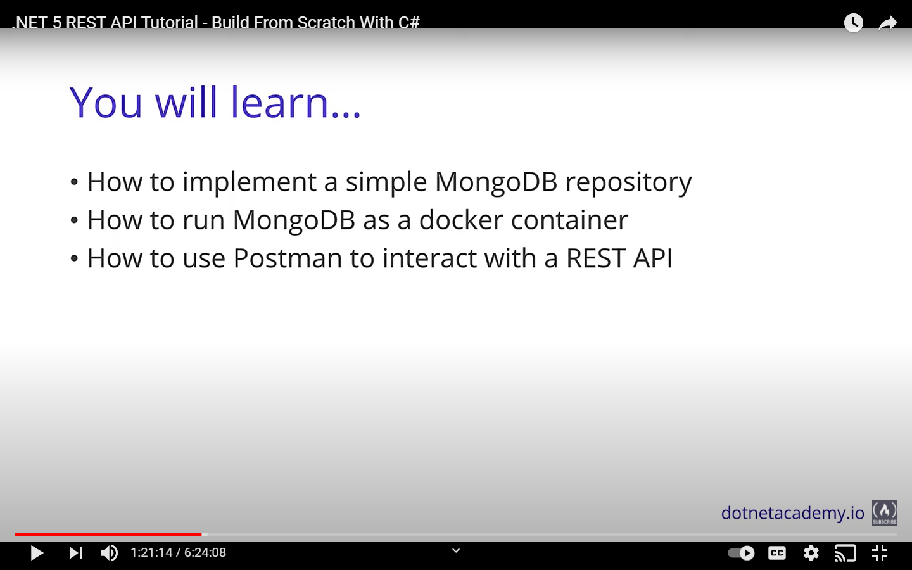

We will be installing docker and run the local mongo db instance

But for our case we will try with Atlas and also the local installation i.e. Compass

Mongo DB – Document database… JSON documents are stored

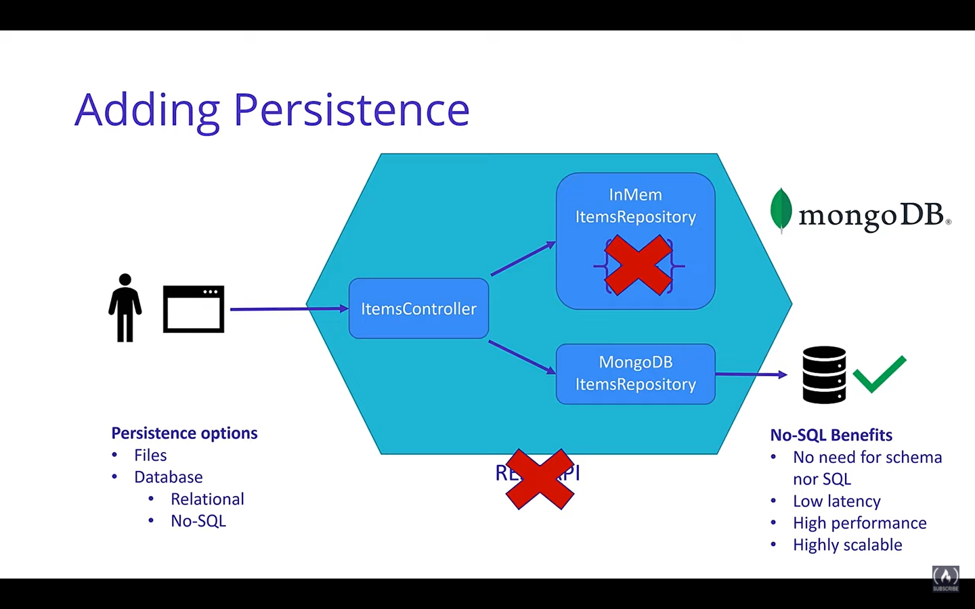

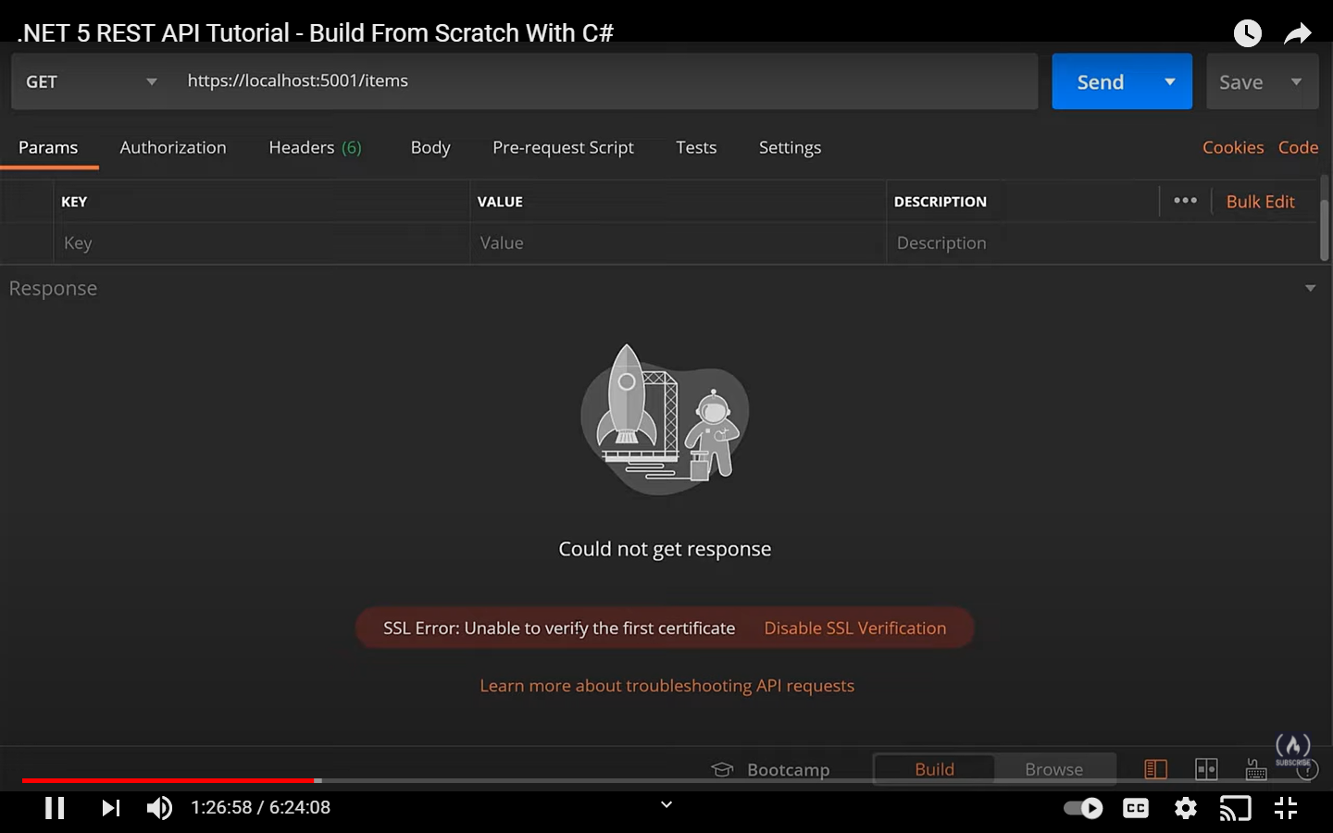because of SSL verification that POSTman is performing and that kind of verification is not possible with the kind of self signed certificate that comes with postman

So you can disable that one.

We need MongoDB nuget Package

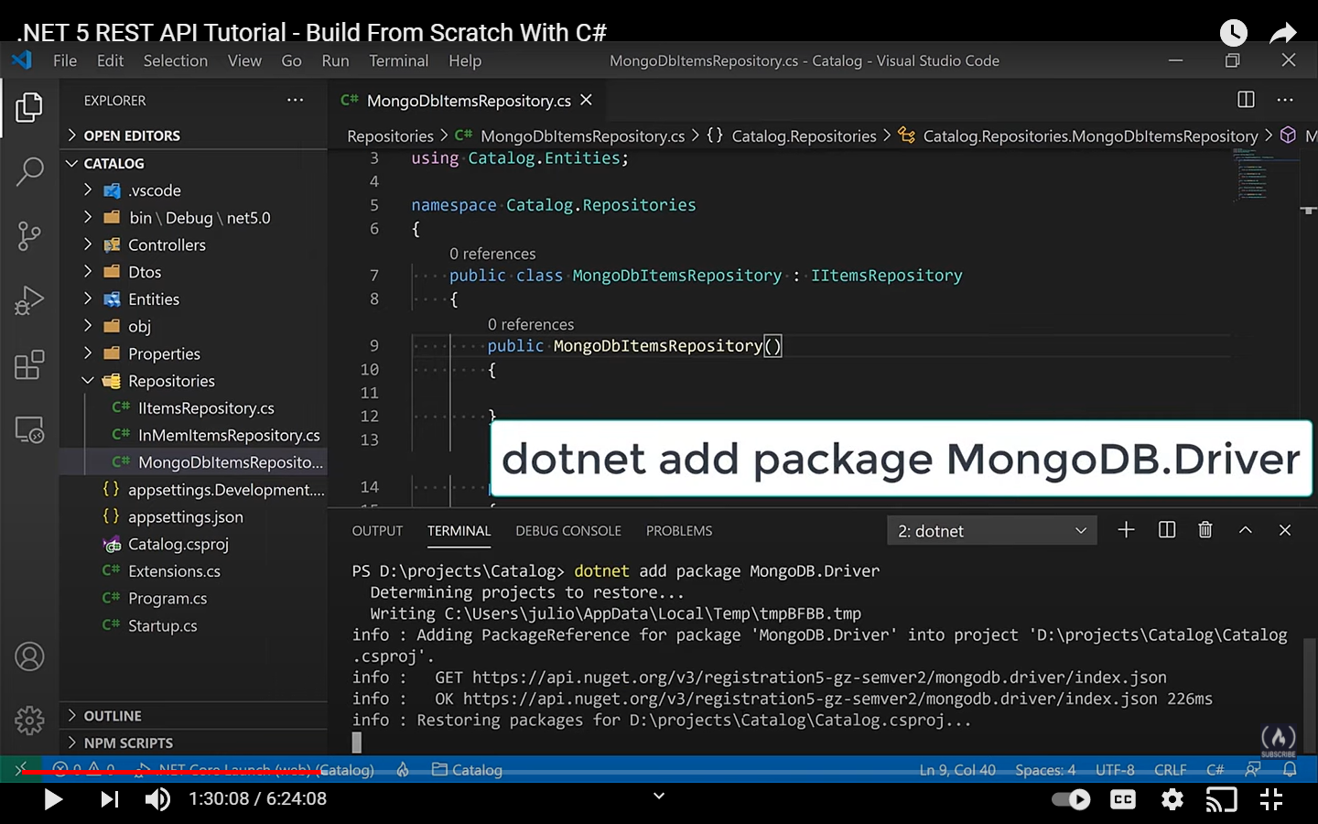

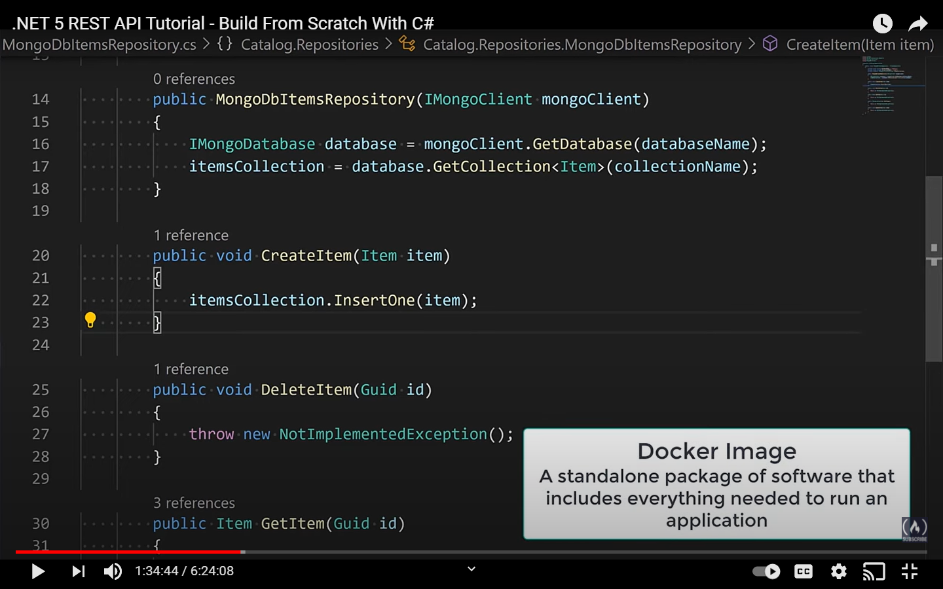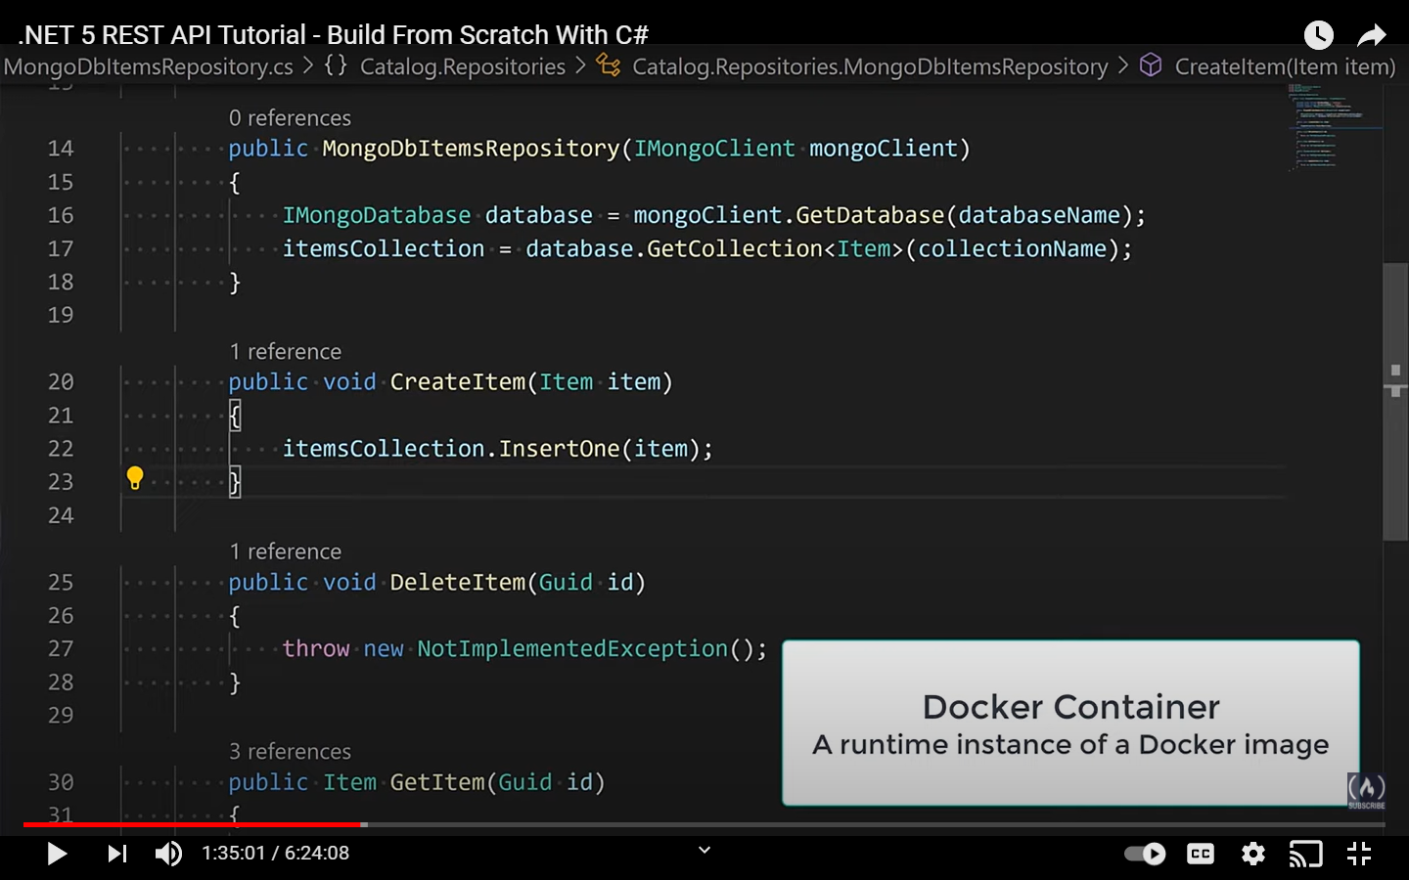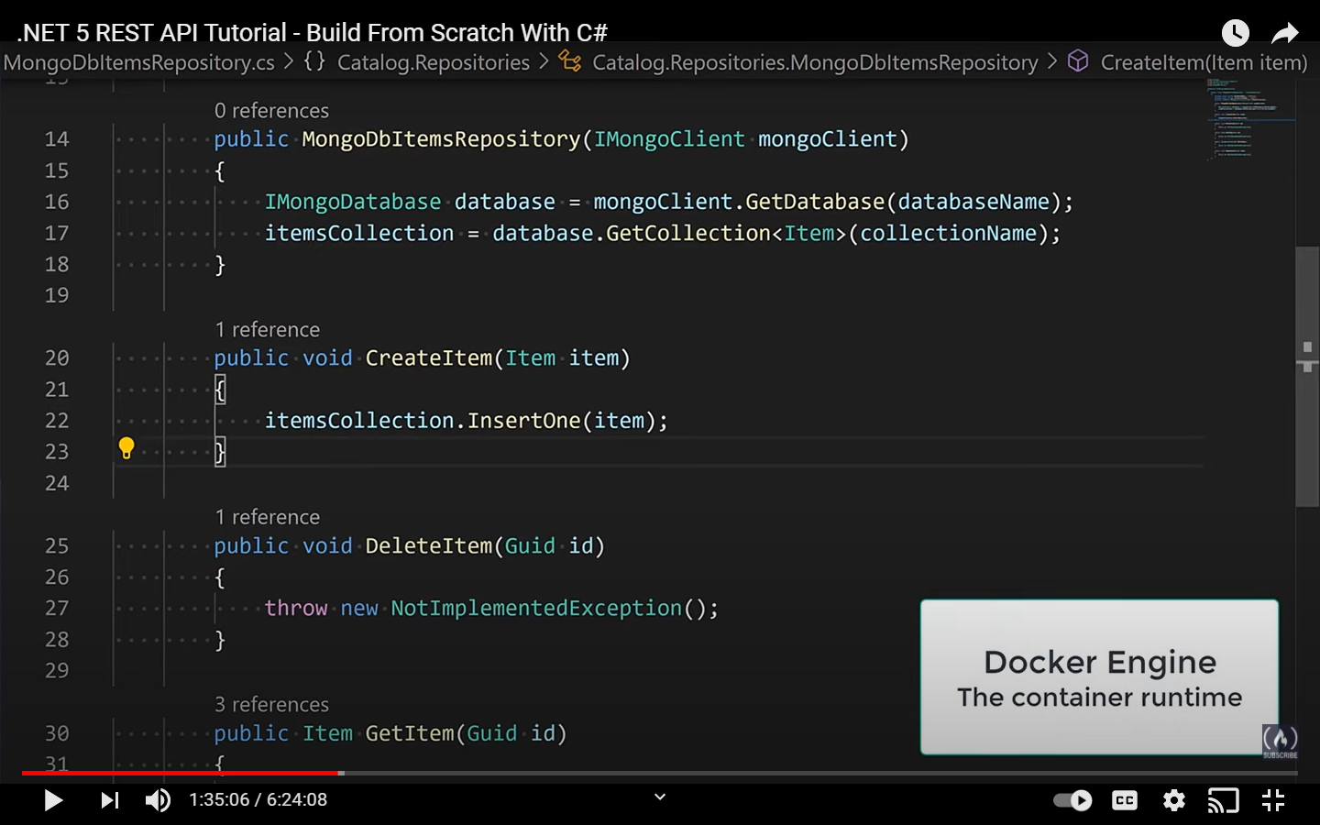

**docker run -d --rm --name mongo -p 27017:27017 -v mongodbdata:/data/db mongo**

Above command is to download the docker image. After this docker image will be there and docker container will be running

27017:27017 left is the external one and right one is actually mongodb port. SO the right has to remain same but left can be changed.

mongodbdata:/data/db mongo – left is local volume but right is the volume in the docker

Initially the image will be downloading from the docker hub

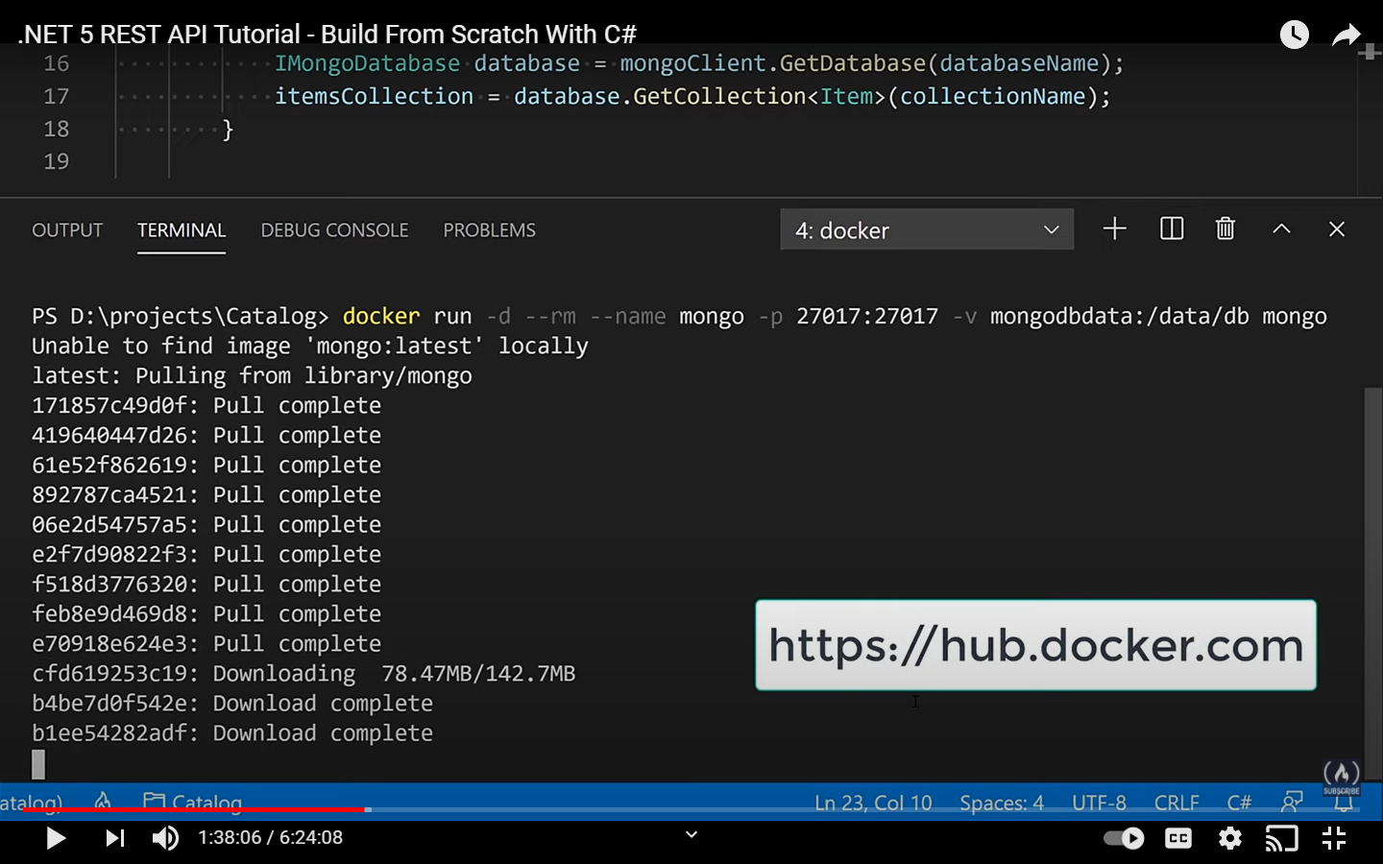

Below screen shows that docker is running and it is running at 27017

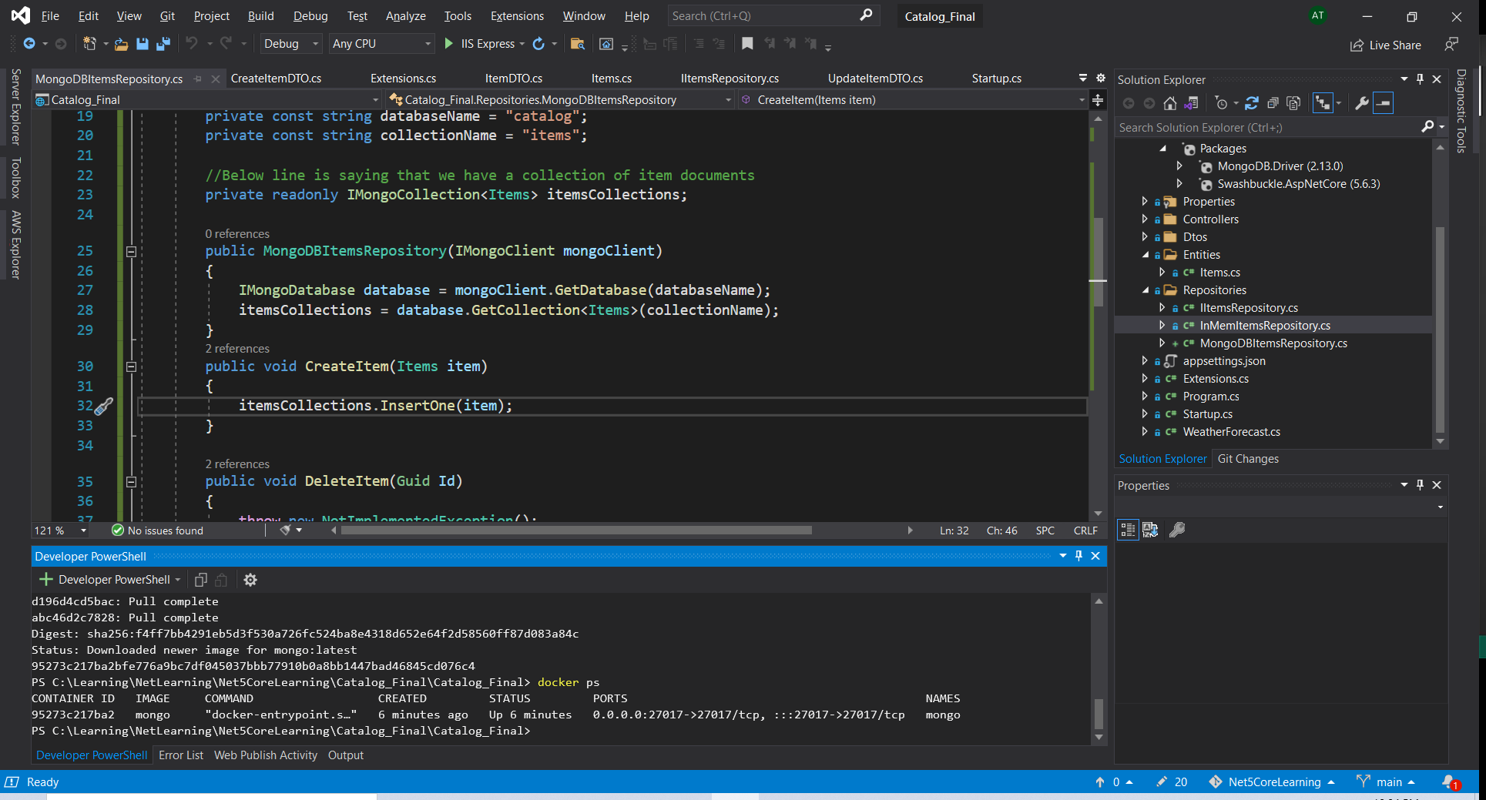

Configuration will look like this

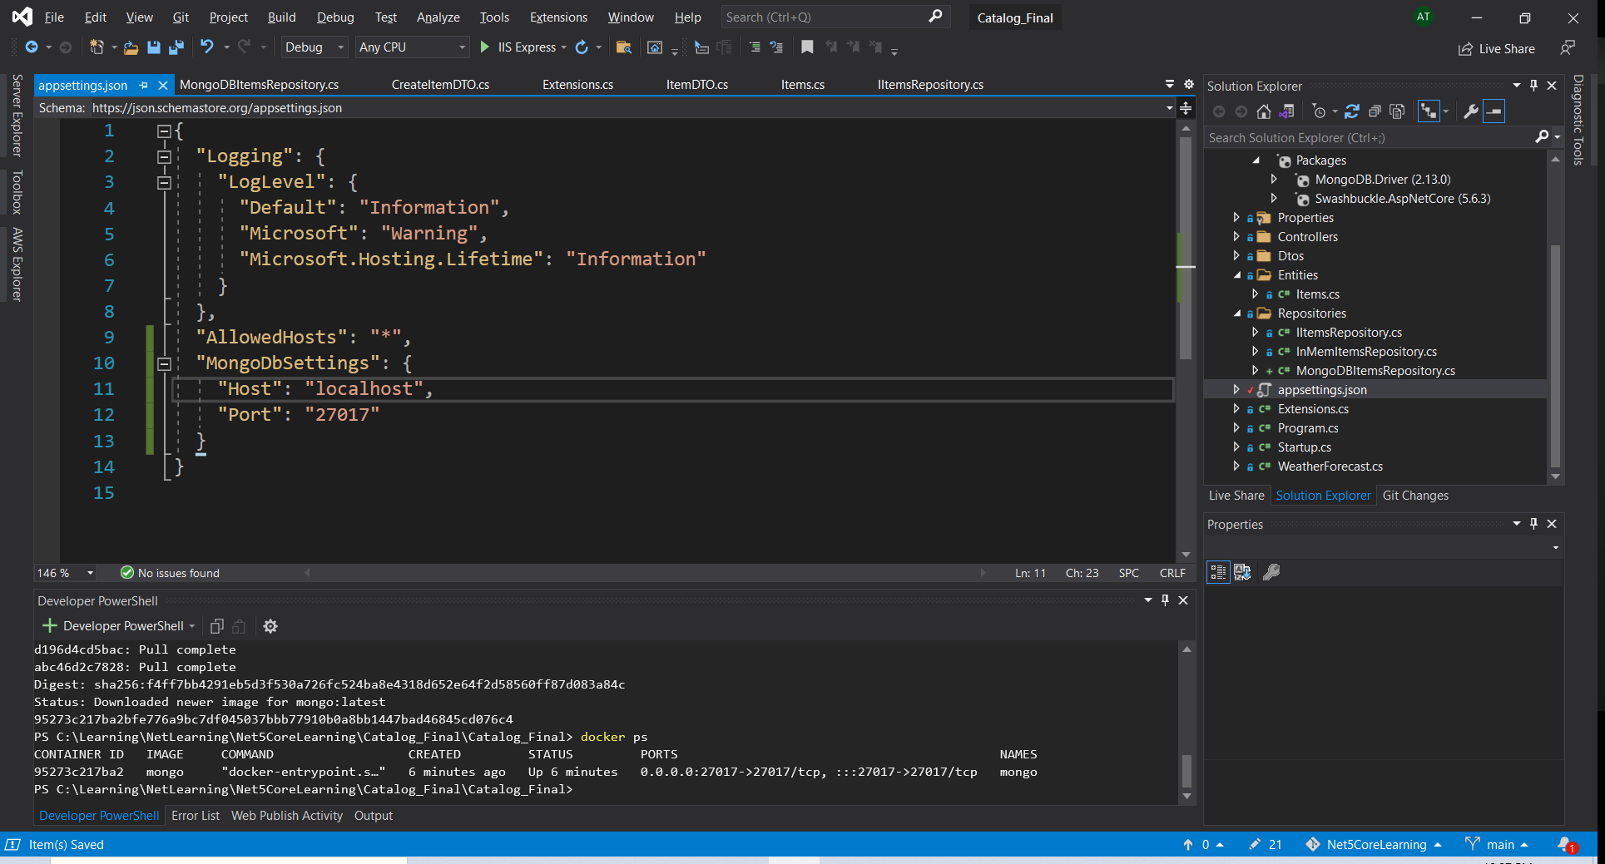

Localhost because the db is running on my local machine and port 27017 because that’s the port that we opened

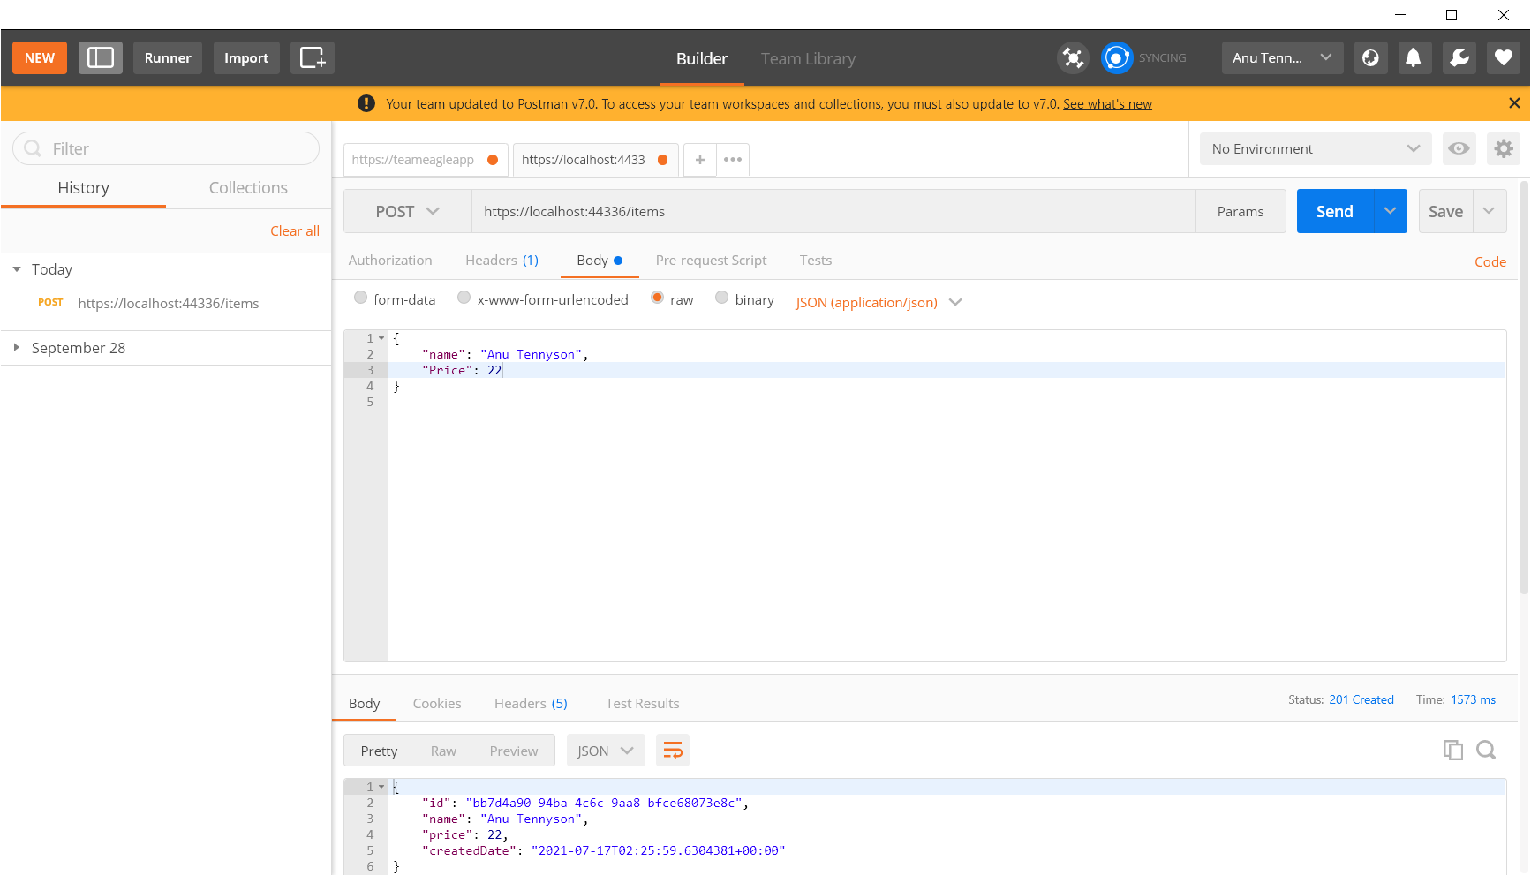

Item got created. 201

Below highlighted is the header that we are returning from our controller

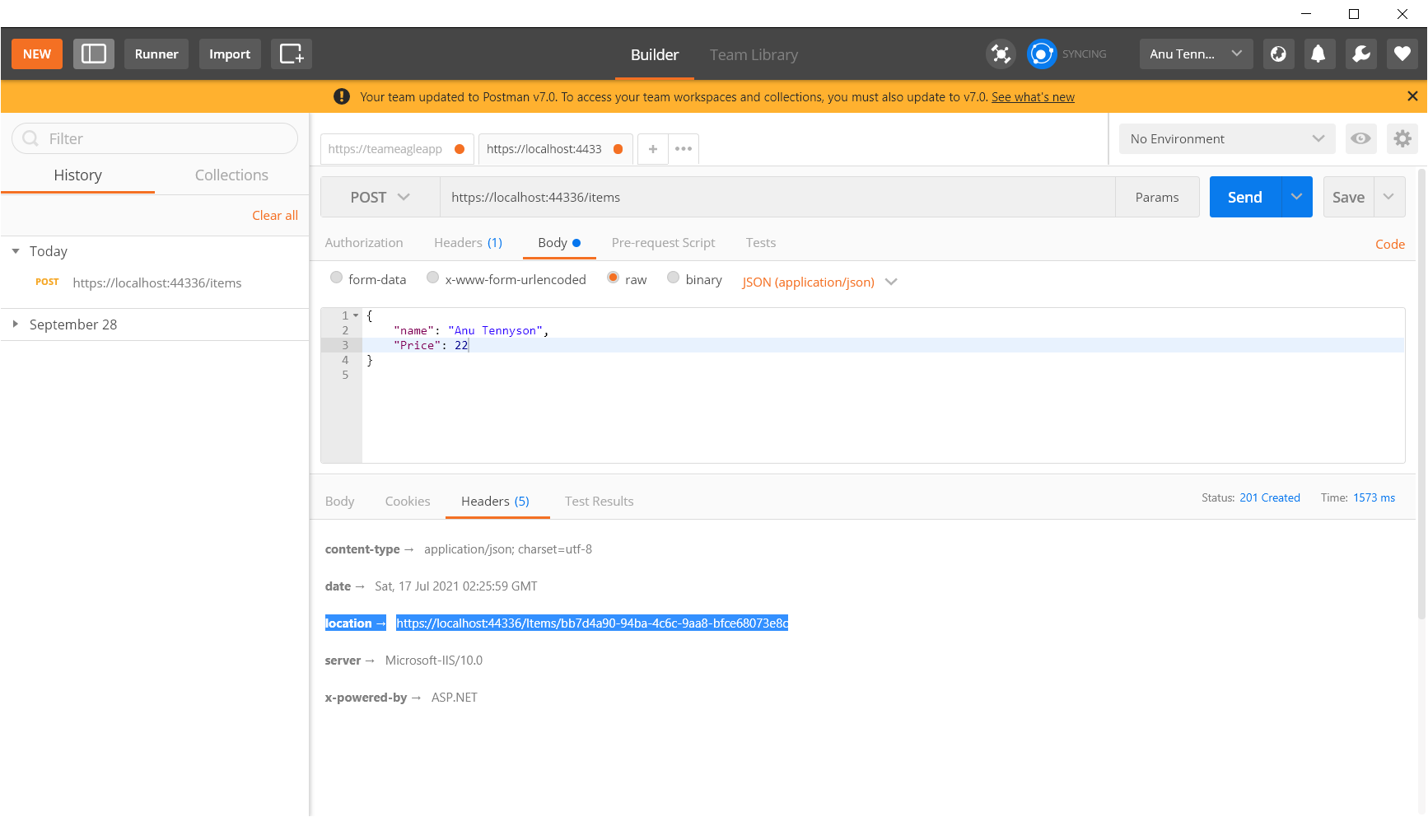

For connetcting to MongoDb there is a extension that comes in VSCode that can be used

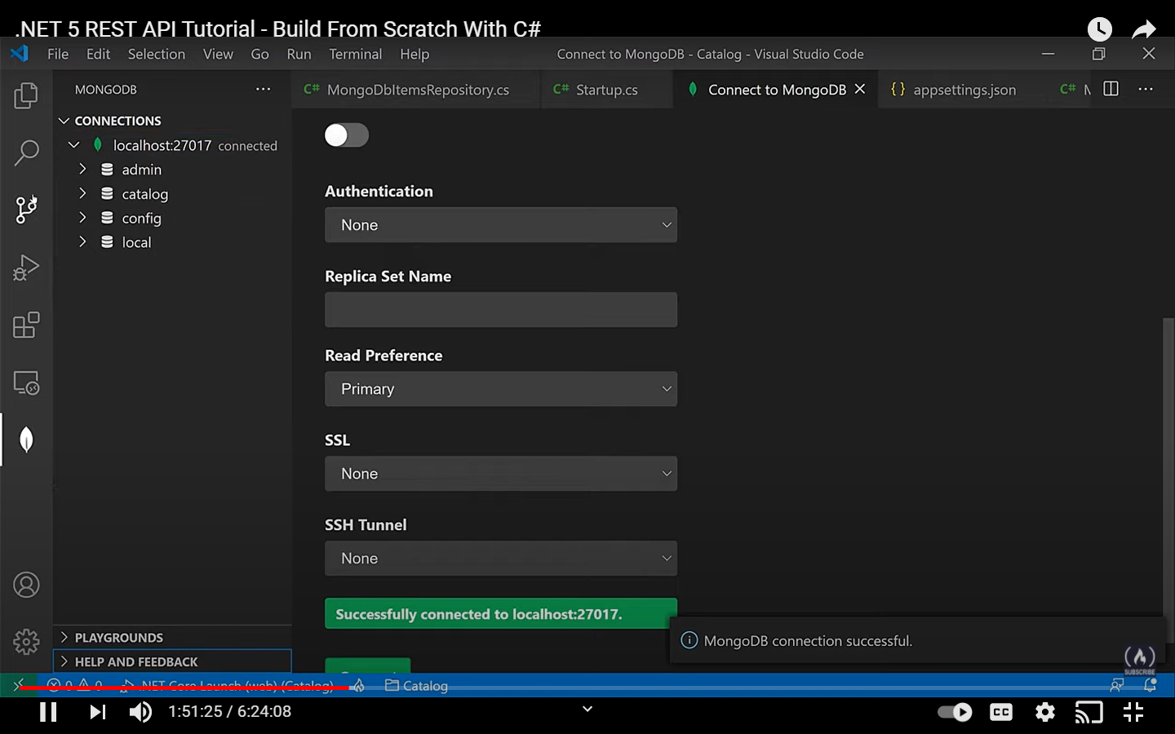 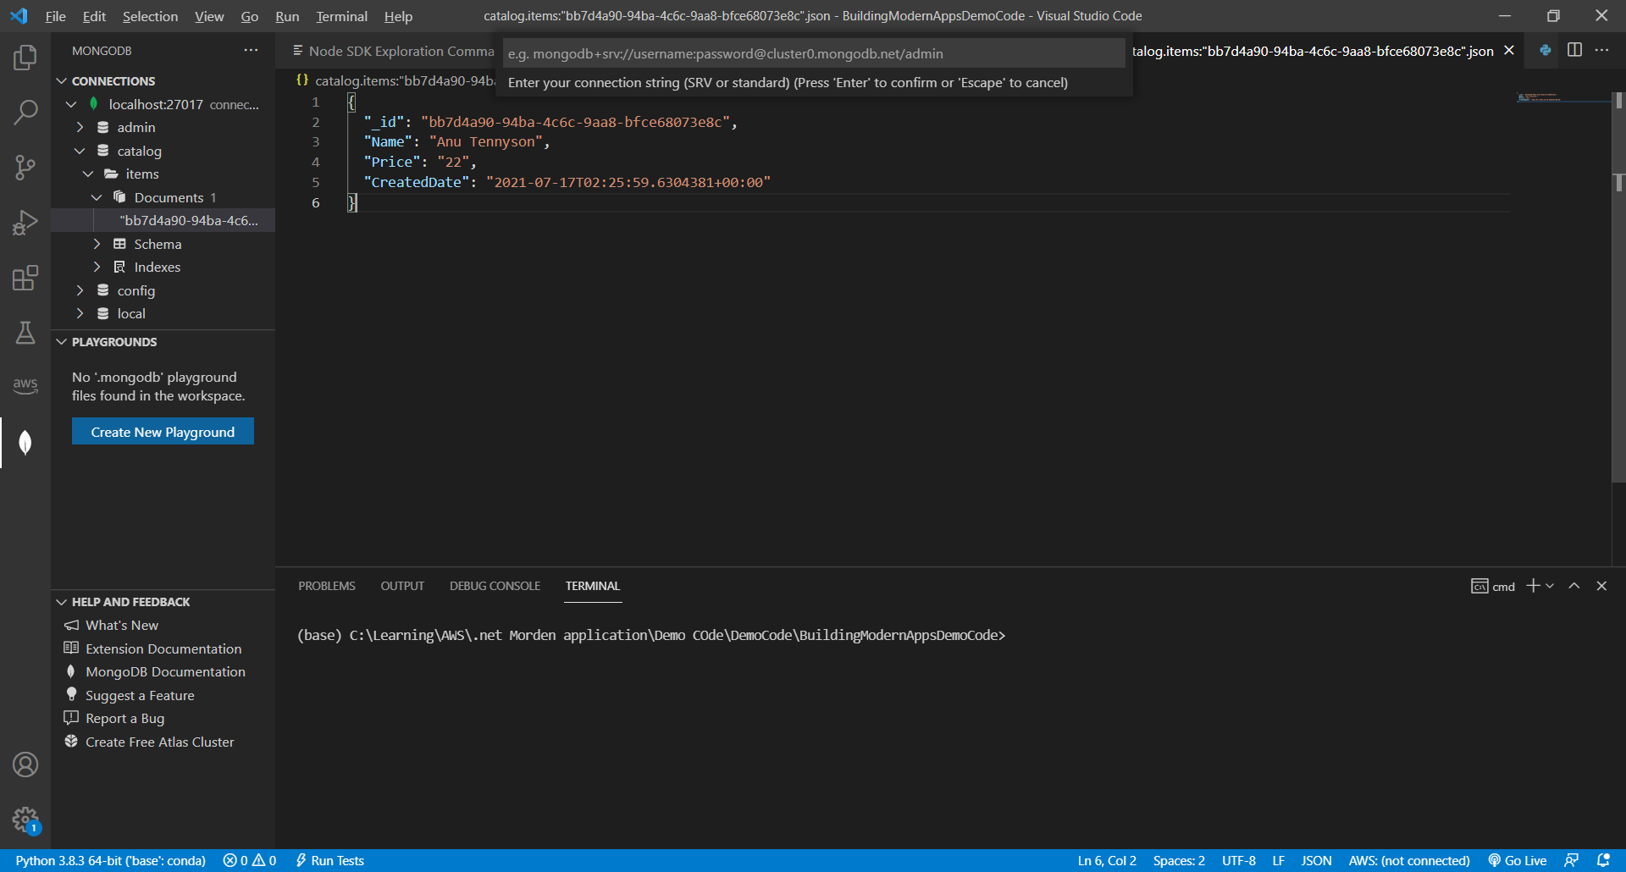

Look at the schema as well

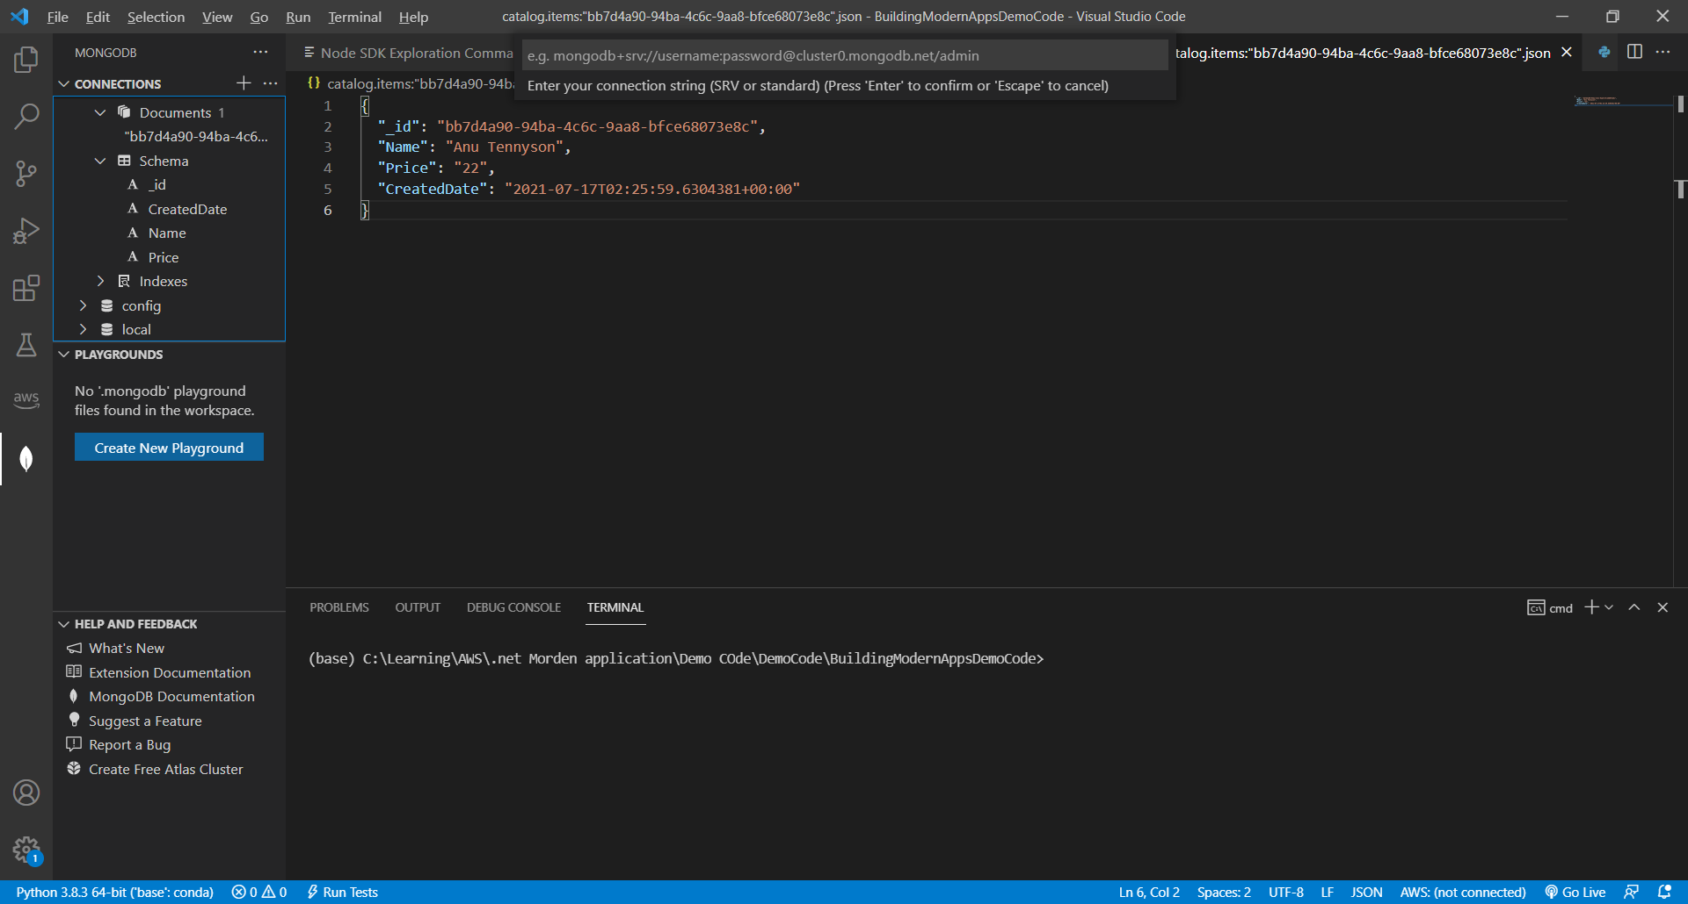

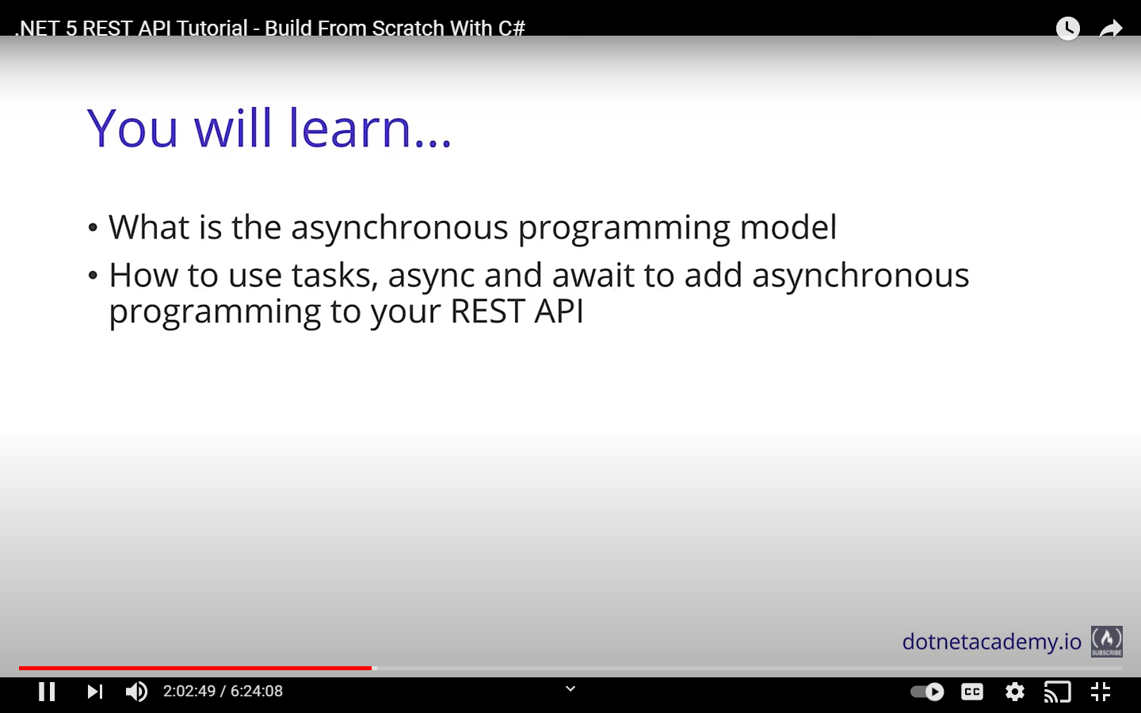

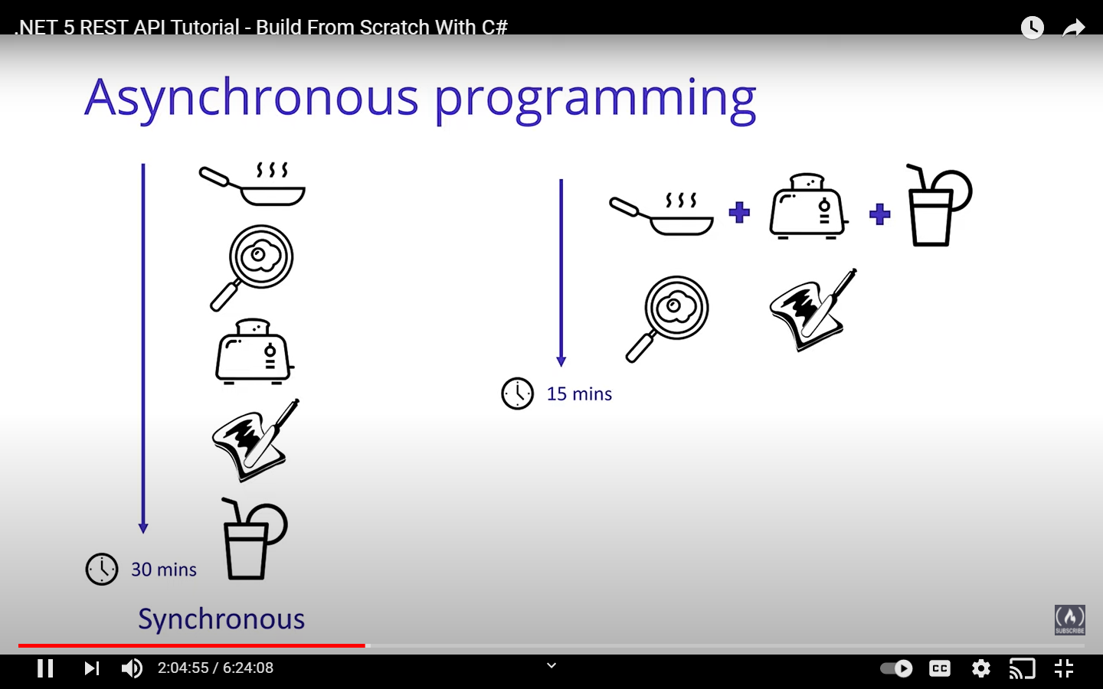

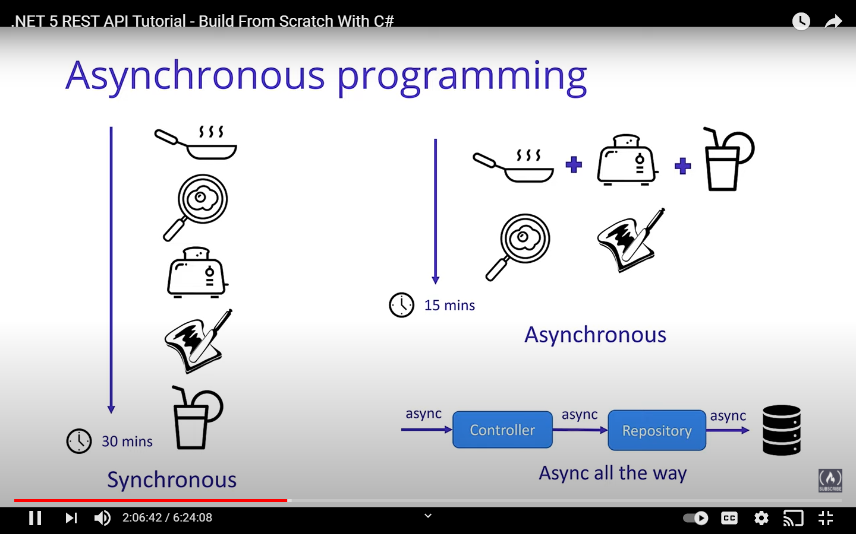

We are not going to wait for the expensive operations to finish rather we will call all the operations async

So, we are going for async all the way

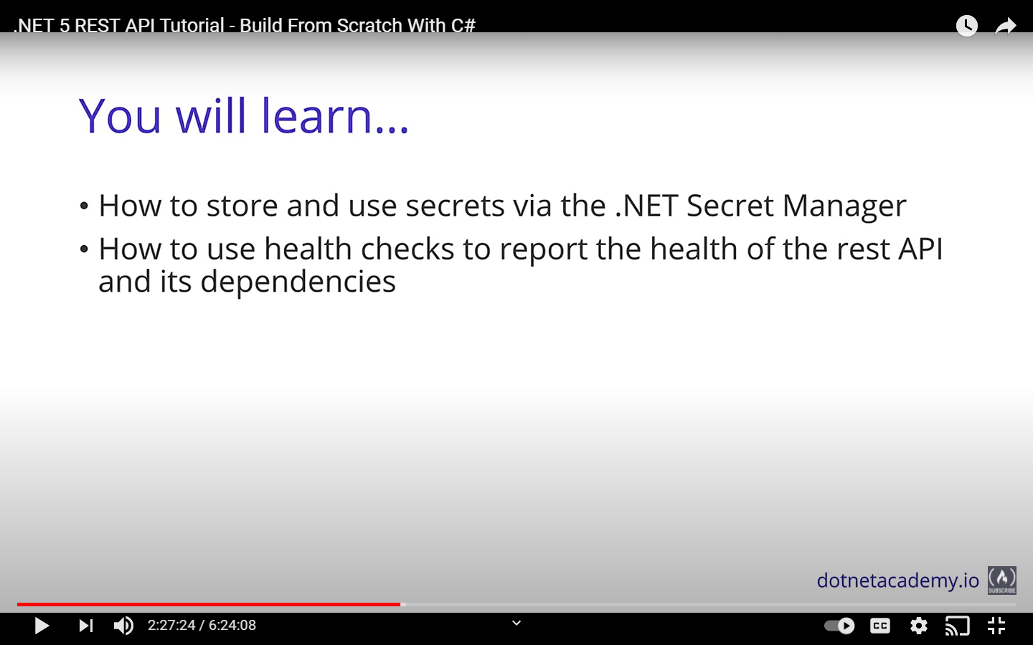 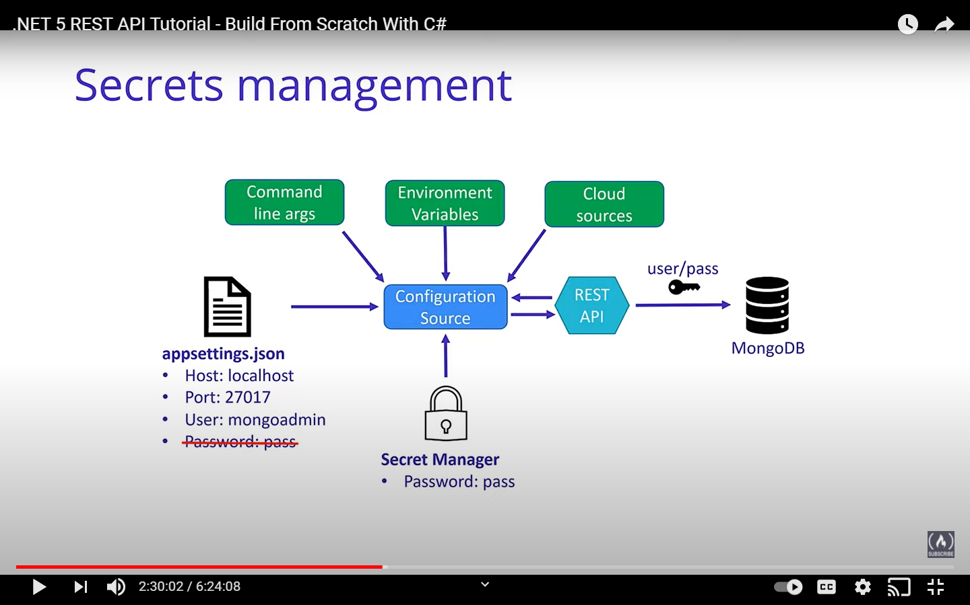

We are not going to store the password in the appsettings file rather it will be stored in secret manager

docker stop mongo

Above command is for stopping a docker container

Docker volume ls

This command is for checking the volume that is running the docker

For deleting a volume run the below command

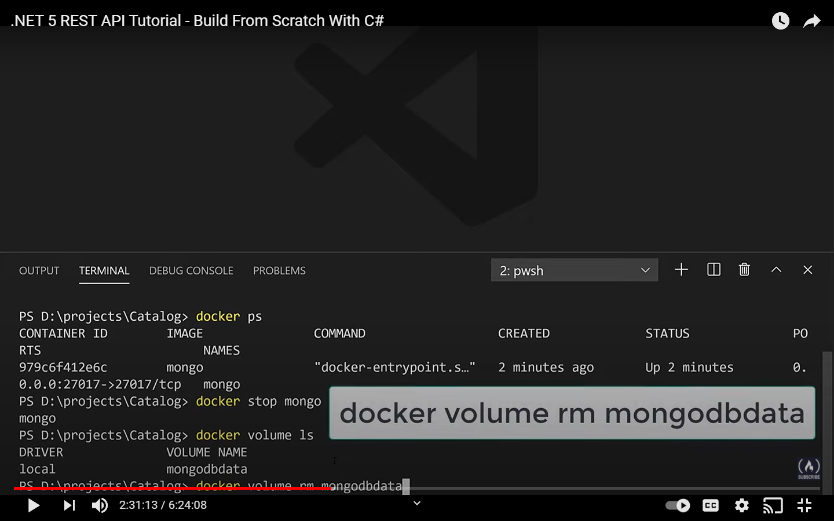

**docker run -d --rm --name mongo -p 27017:27017 -v mongodbdata:/data/db -e MONGO_INITDB_ROOT_USERNAME=mongoadmin -e MONGO_INITDB_ROOT_PASSWORD=Pass#word1 mongo**

We are going to run above command to get the docker running with username and password

Below line is for initializing the secret manager

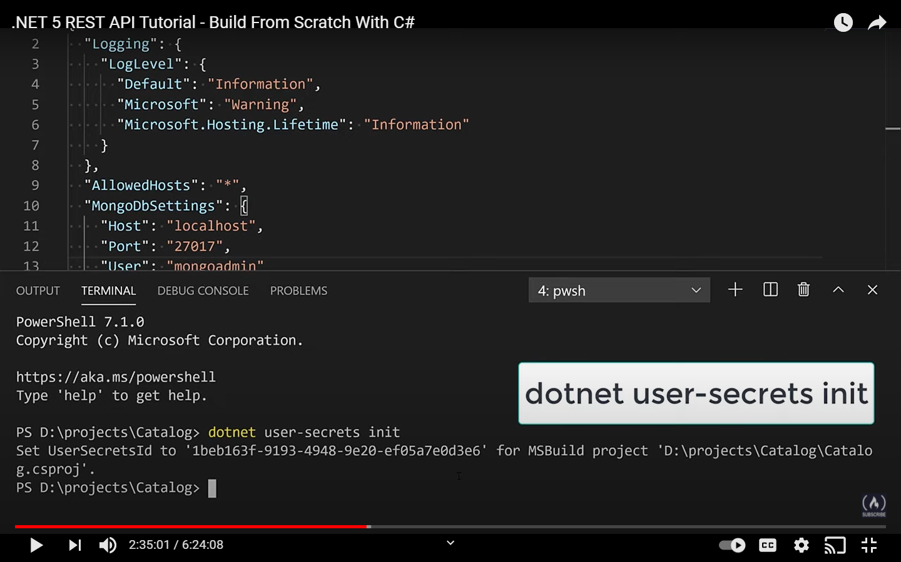

You have to run from within the folder that has the csproj file and run this command

dotnet user-secrets init --project "Catalog_Final.csproj"

the above command will create a usersecretid like shown below

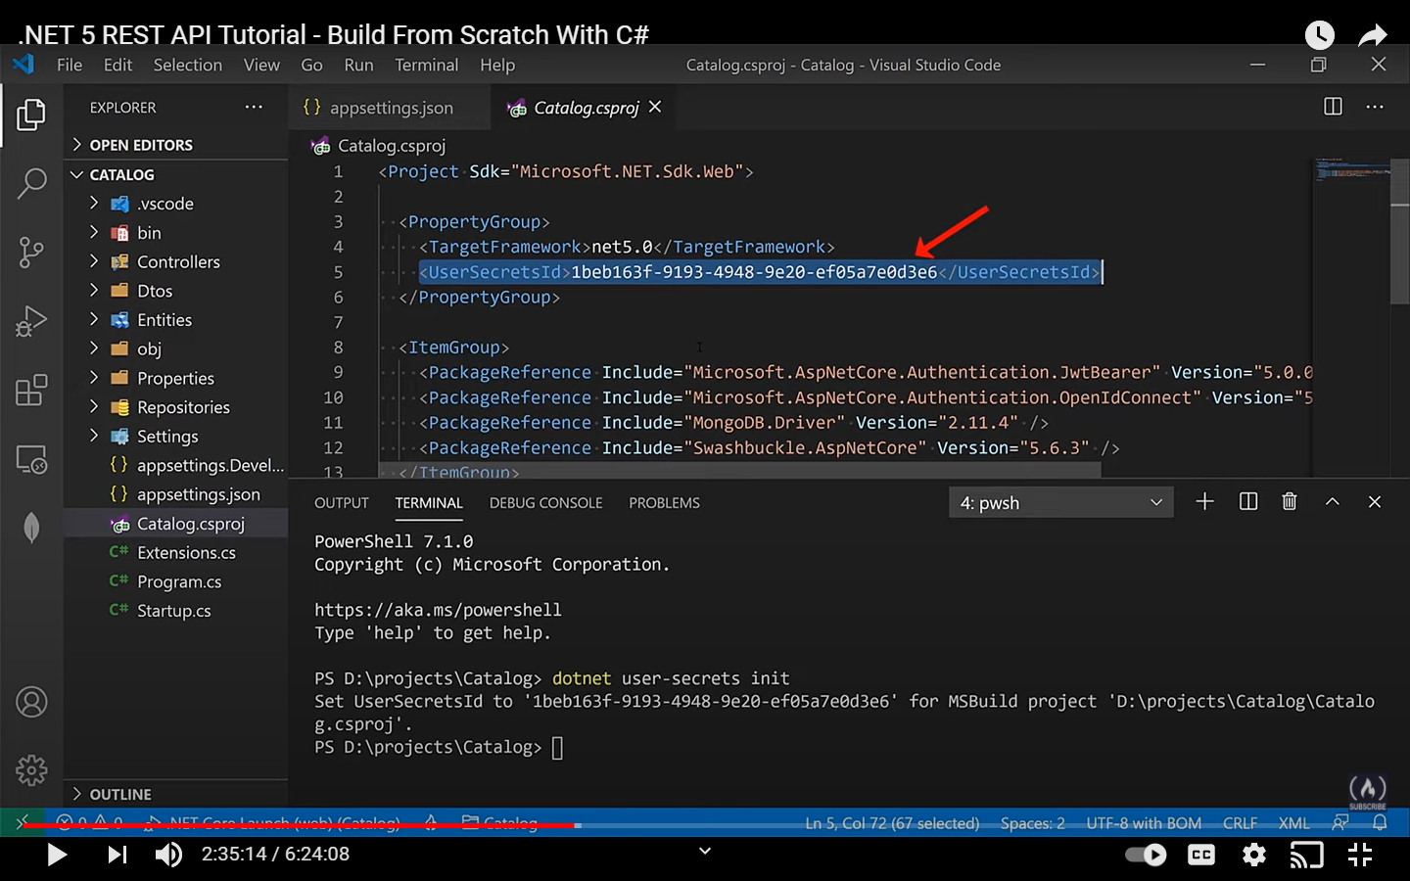

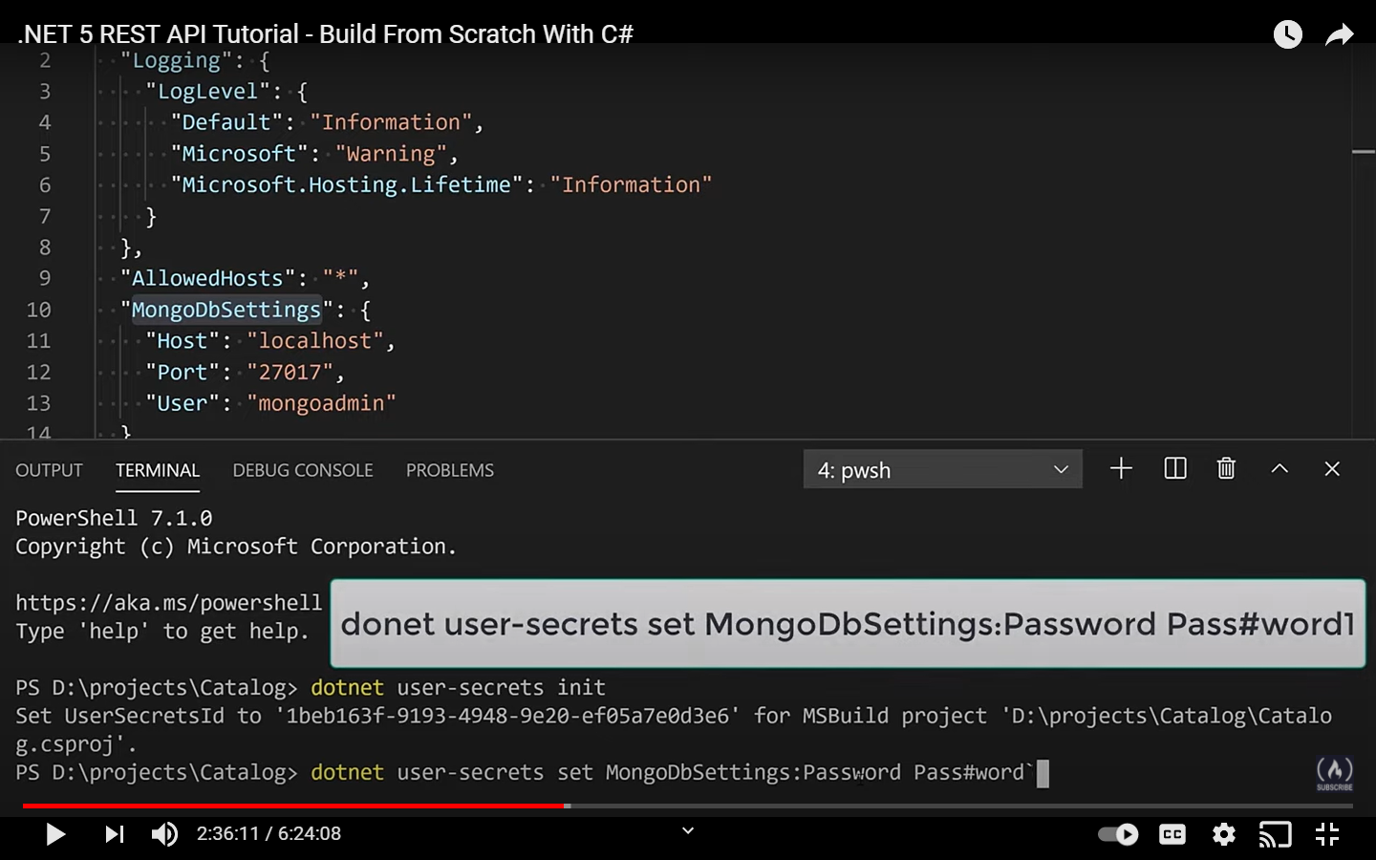

The variable is set in a way that it shows the convention that we have in the appsettings file

Just for reference -> CreateDefaultBuilder in program.cs is responsible of injecting the secret manager dependency

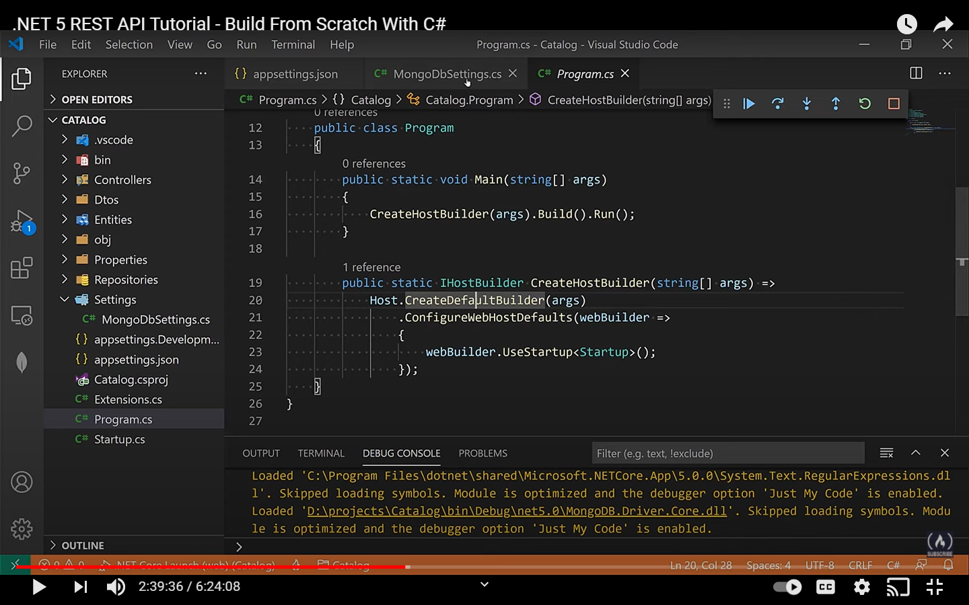

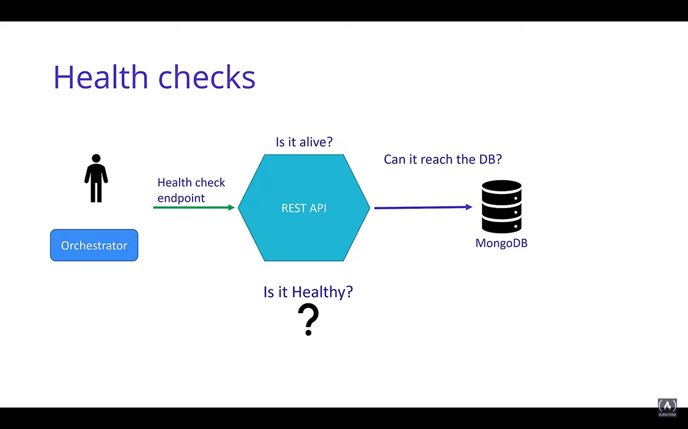

It becomes a lot important if you have a orchestrator system then that system has to know if your system is health or not.

The healthcheck information is added in Startup.cs class inside configureServices class…

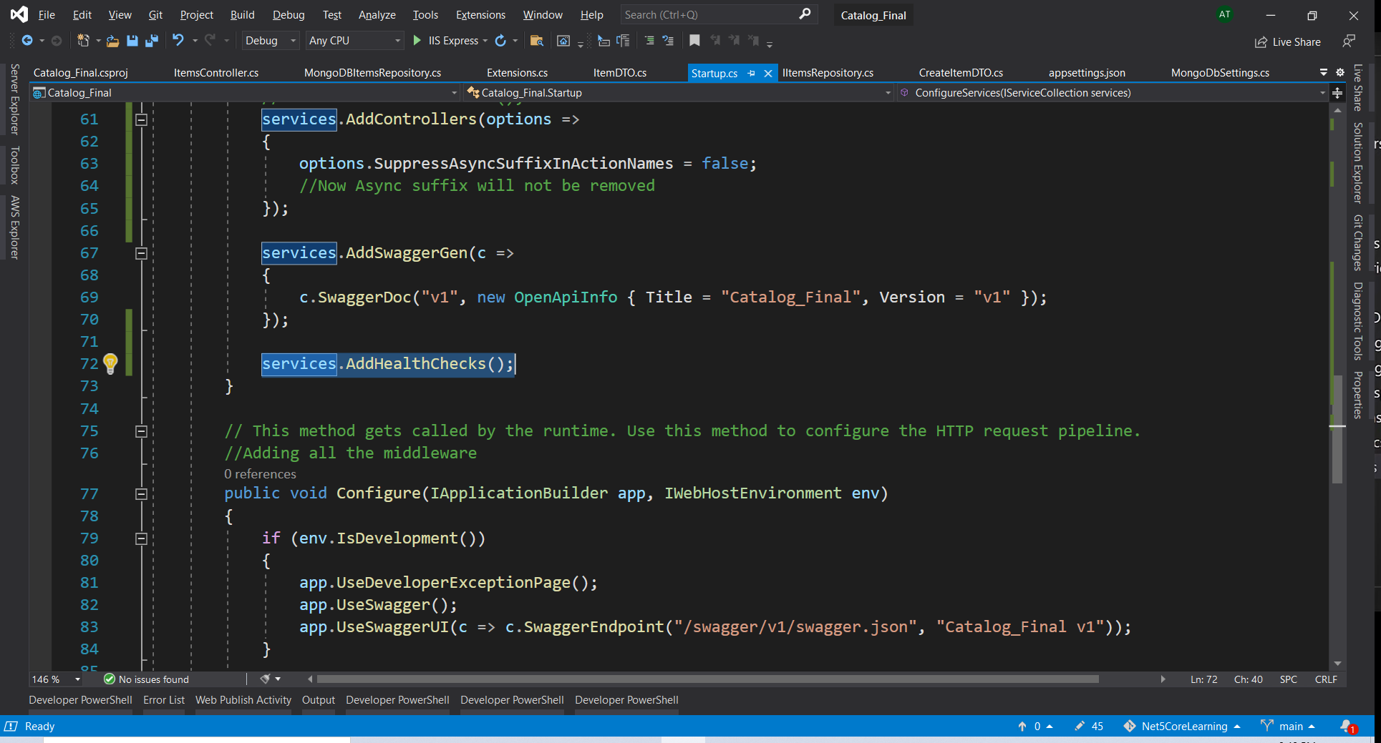

Then you have add the middleware and that will be added in the configure method inside useendpoints

This created a new endpoint

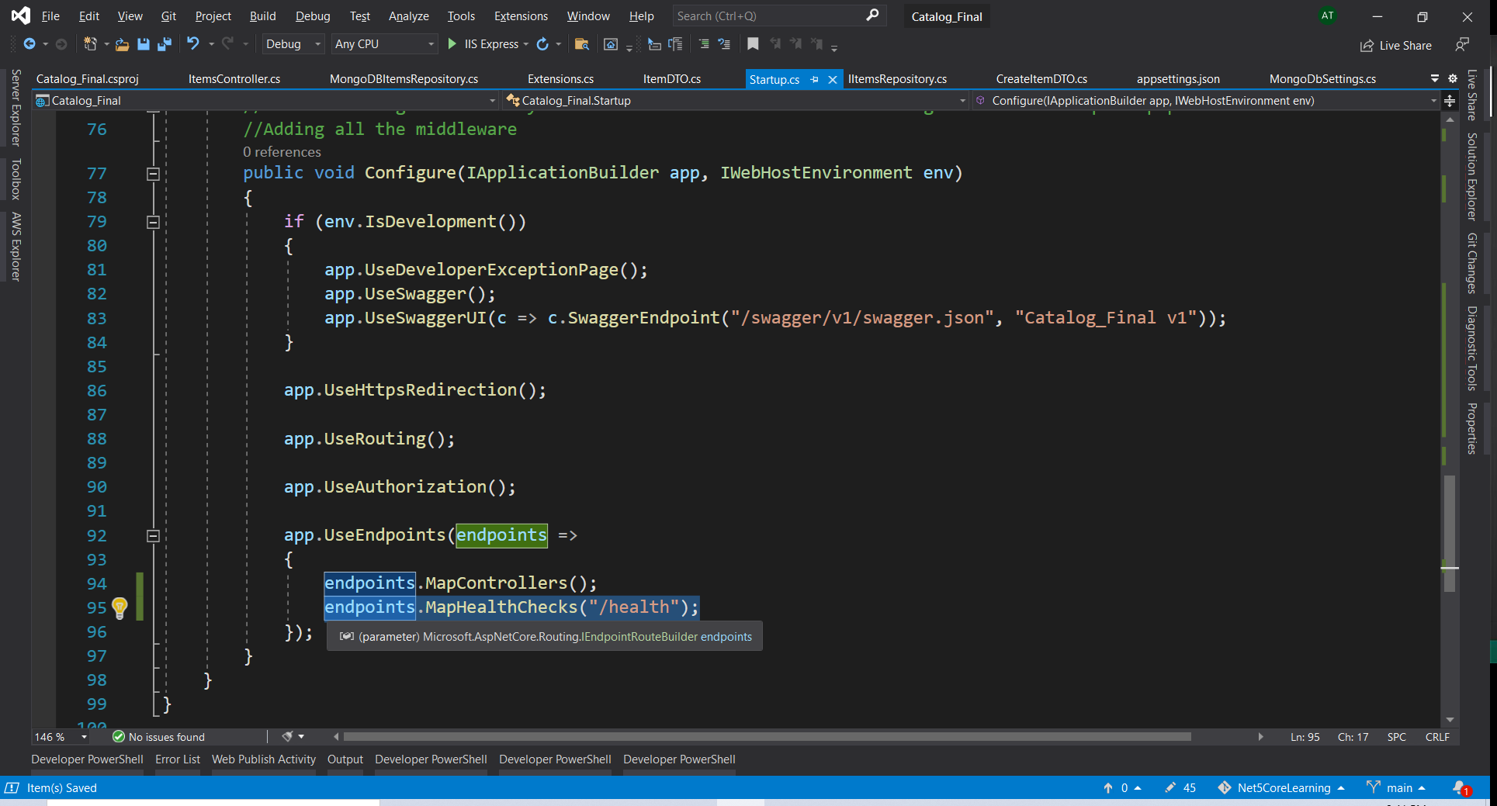

This is a very basic health… if you want custom then you can add custom health checks as well. You can check this using the Postman and you always get a response Healthy

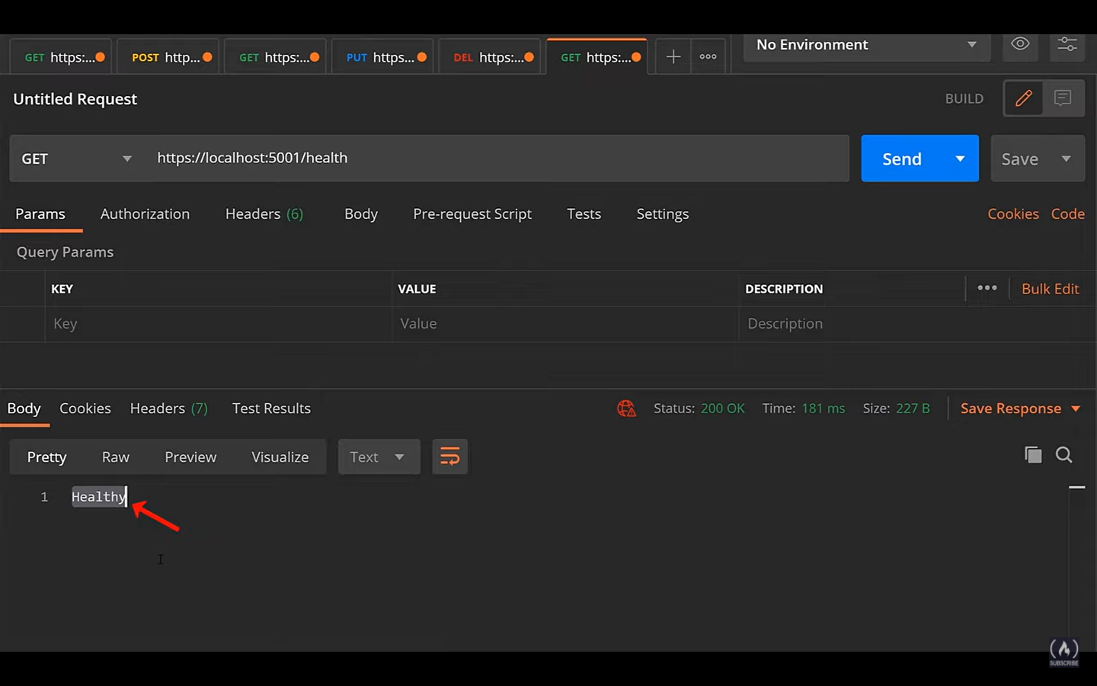

This just gives information that service is healthy and does not provide any information about if the database is healthy or not. So we have depended services like database then we can do something else to make sure to check the health

NuGet package – Asp.net Core Health checks mongoDb

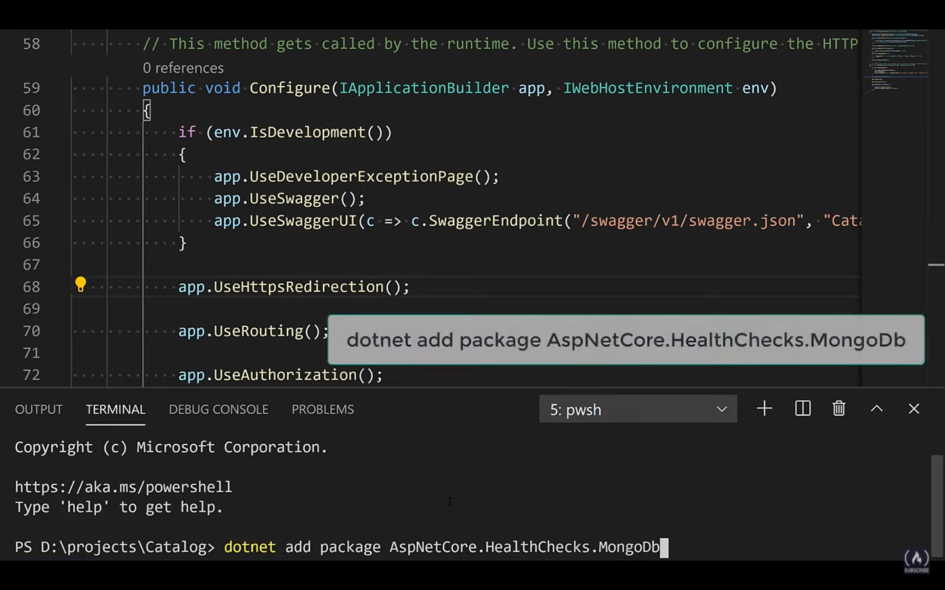

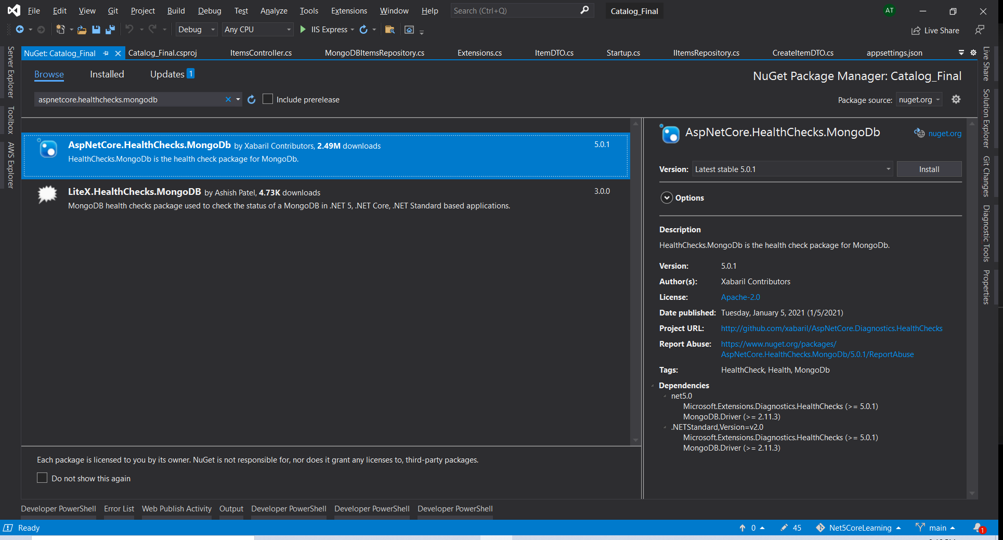

This is an open source project and not part of MongoDb or .net 5

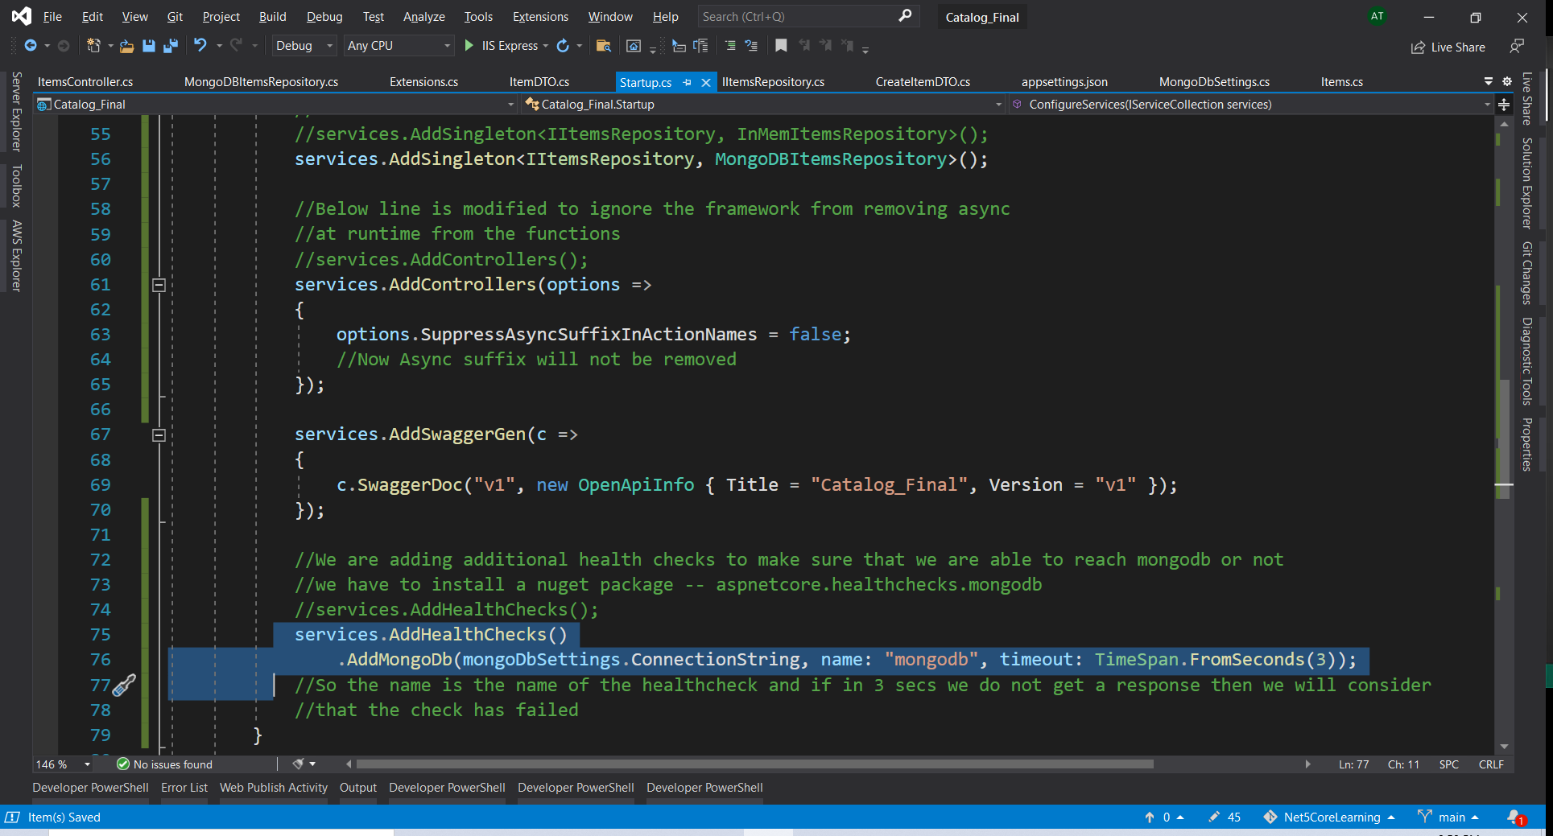

If after making the changes we run

Docker stop mongo

To stop the container

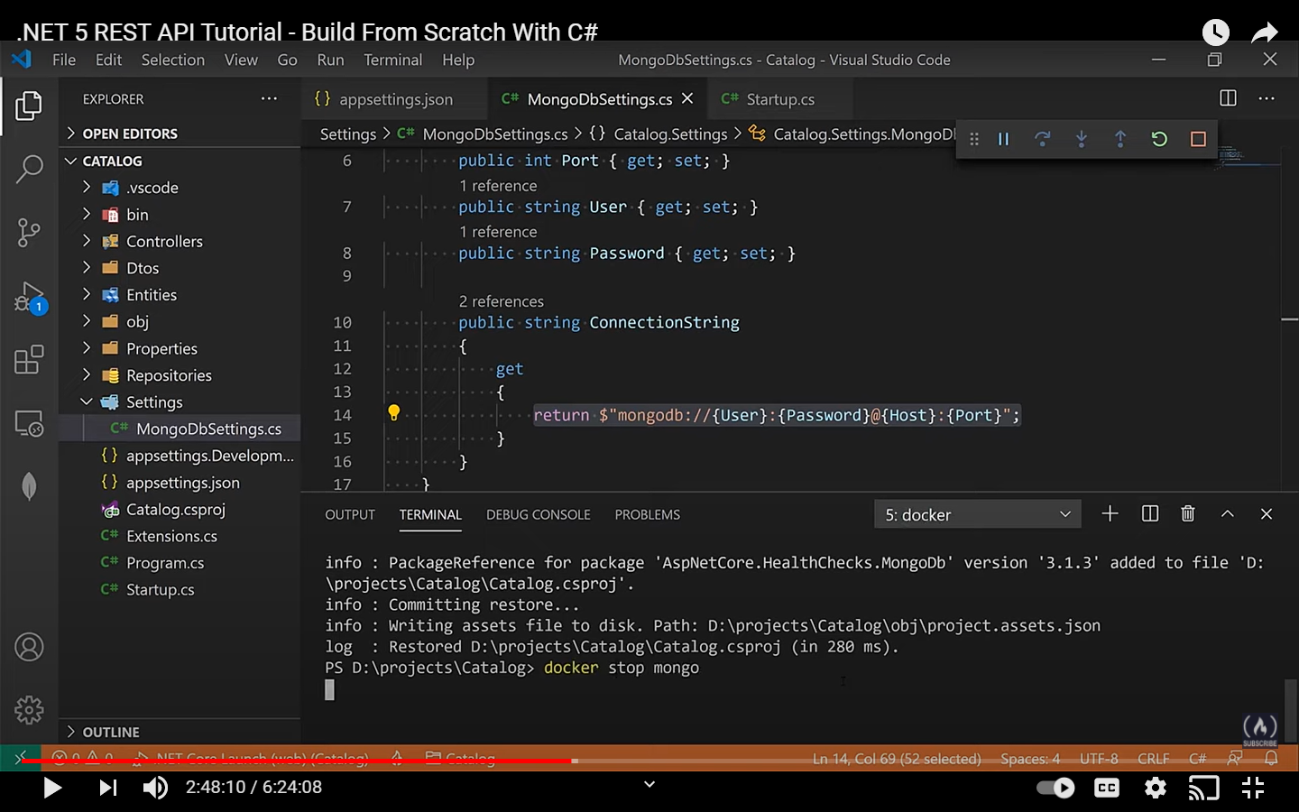

Then after 3 seconds we will get unhealthy

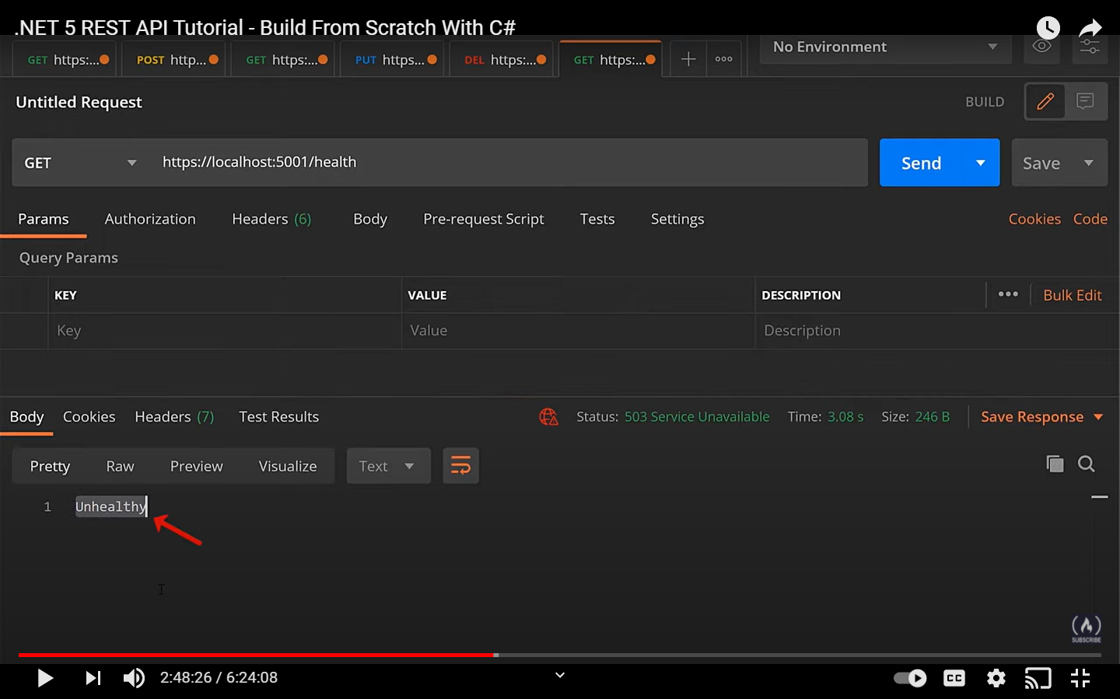

We can have an approach where we can have different health end points for ready endpoint and the live endpoints

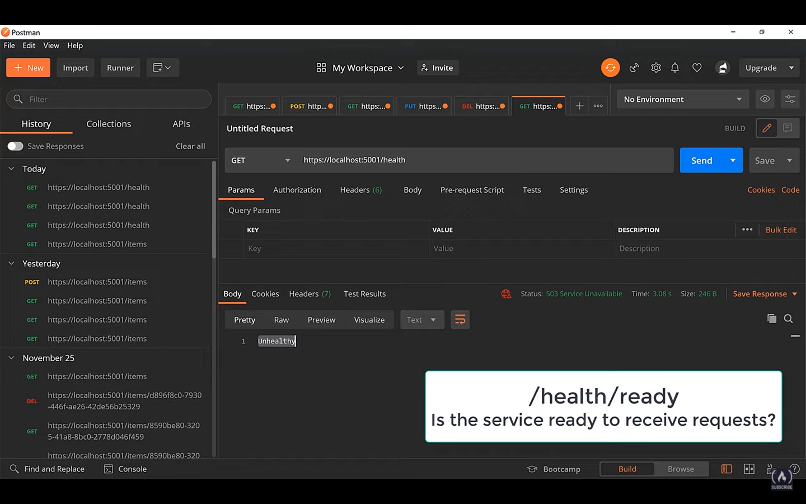

Ready endpoint – if service is ready to receive the incoming request. IN our case it will mean if the database is ready to go and it can receive the request or not

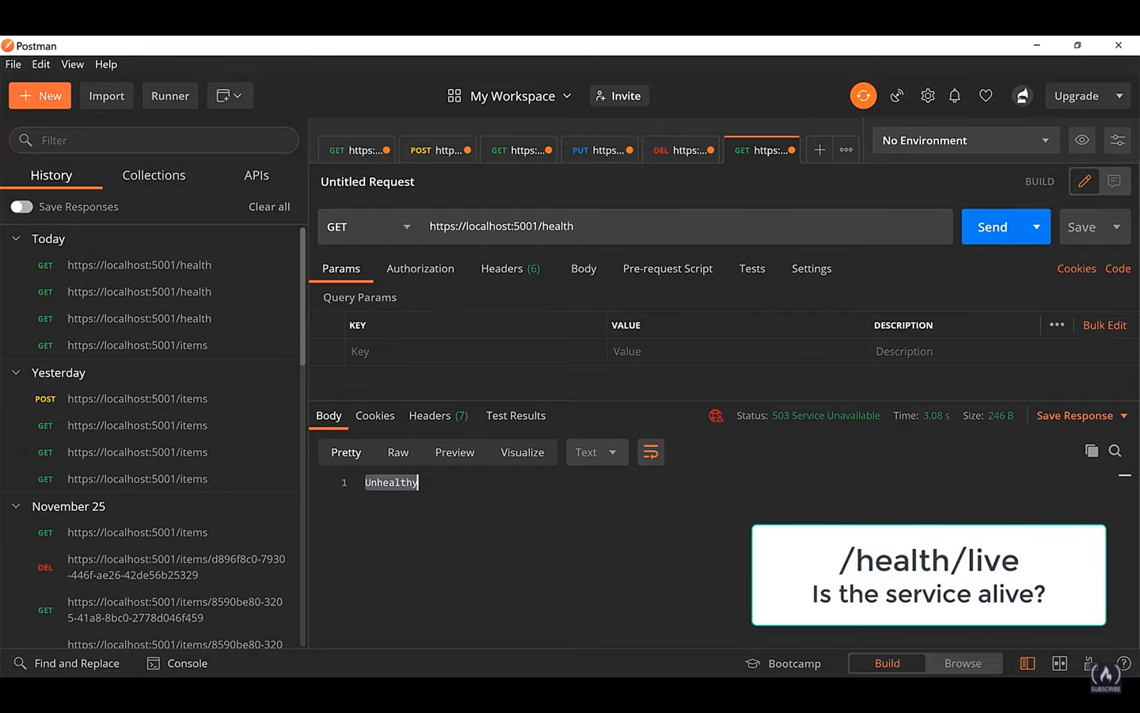

Live endpoint just tells that if just the service is up or not

First you have to add tags in configureService section like shown below

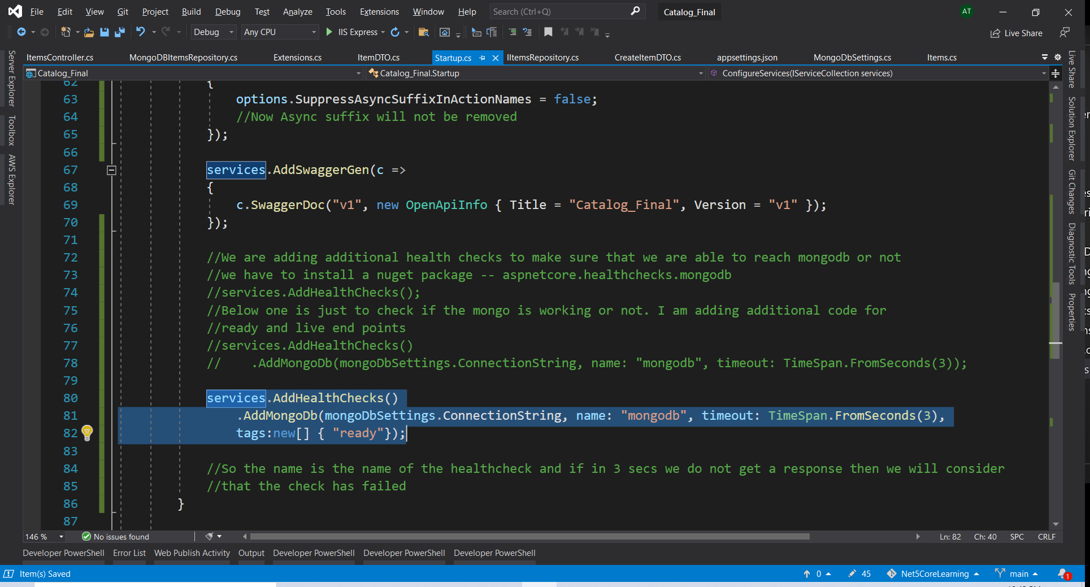

Additional code that goes in the configure function to add middleware

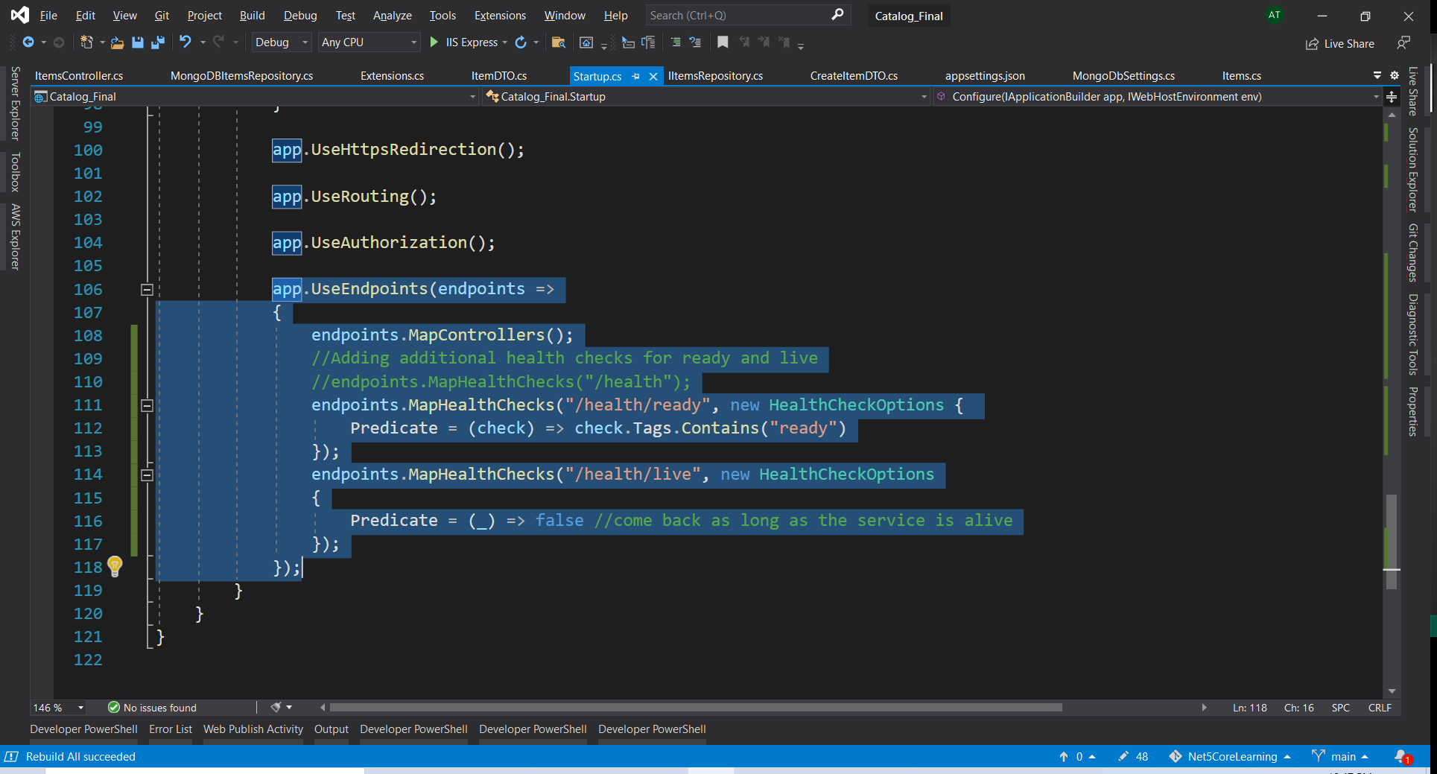

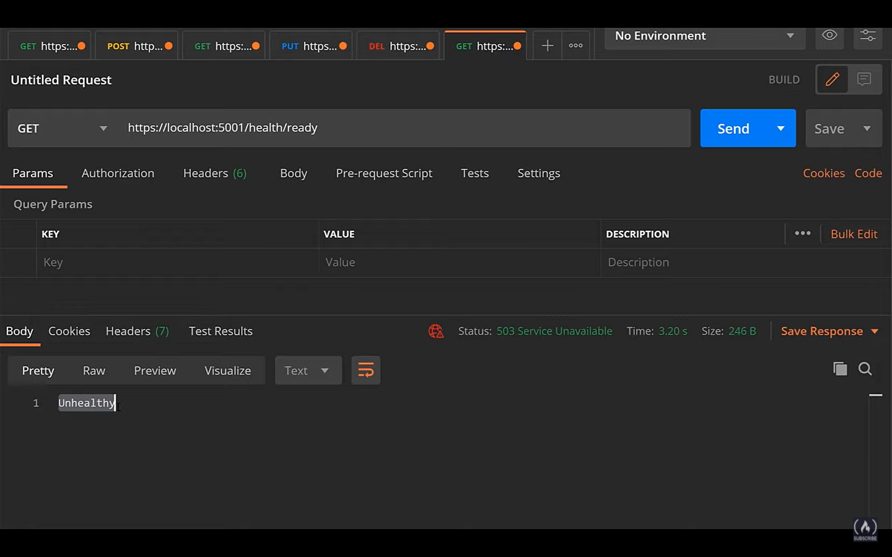

Above one is docker is down

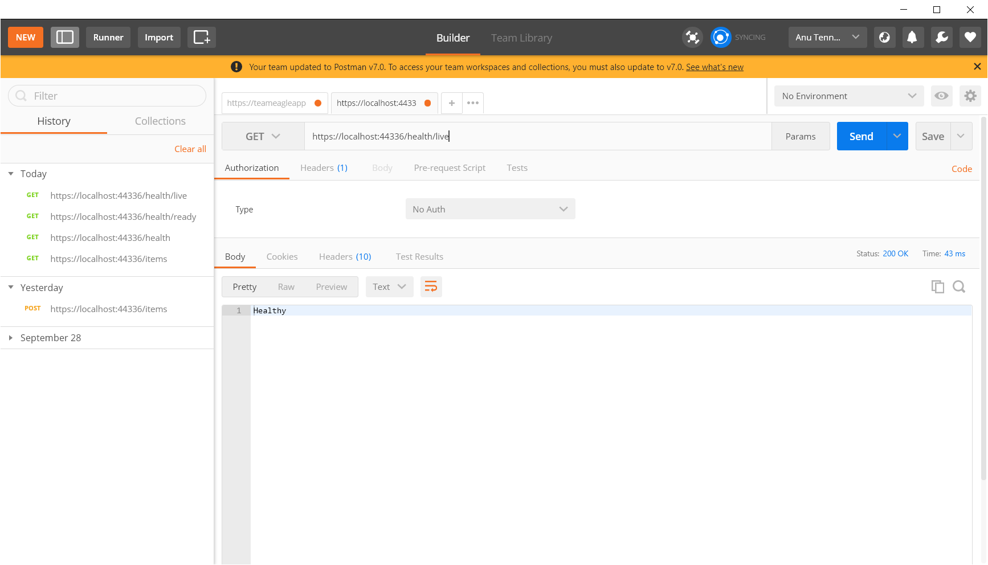

You can even customize the message that you are going to get in response

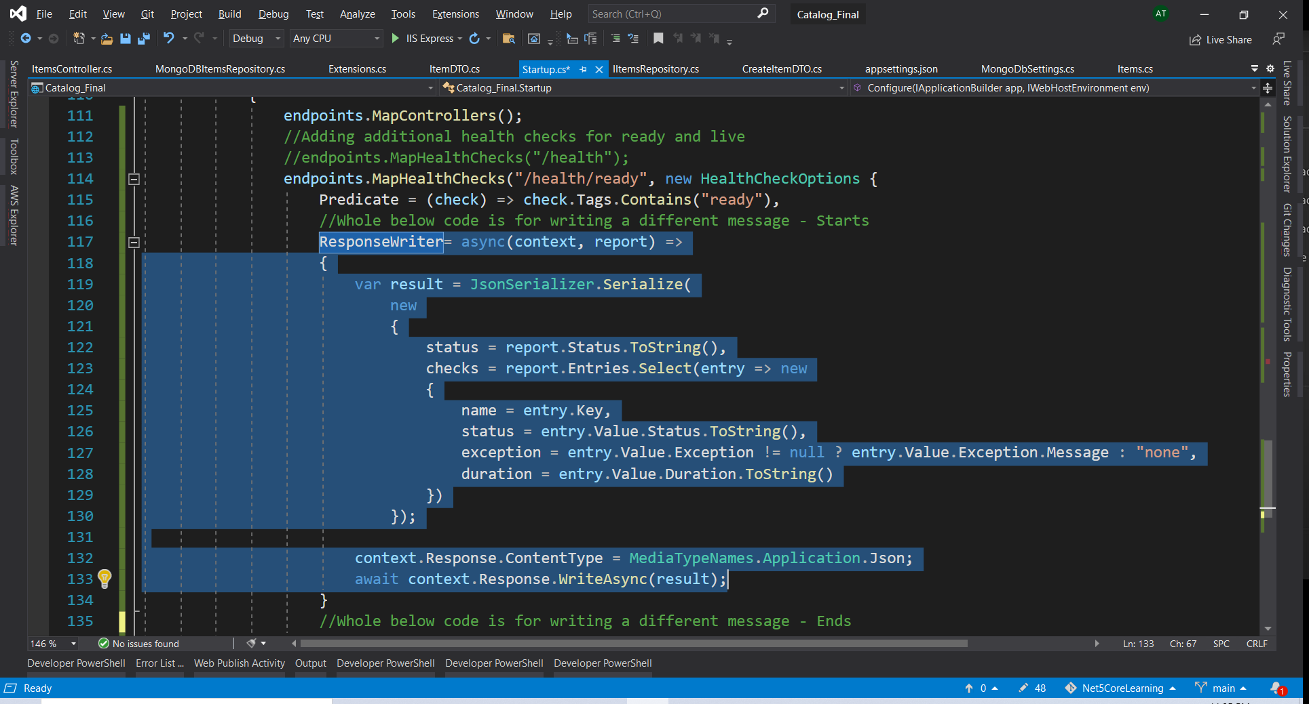

After making changes

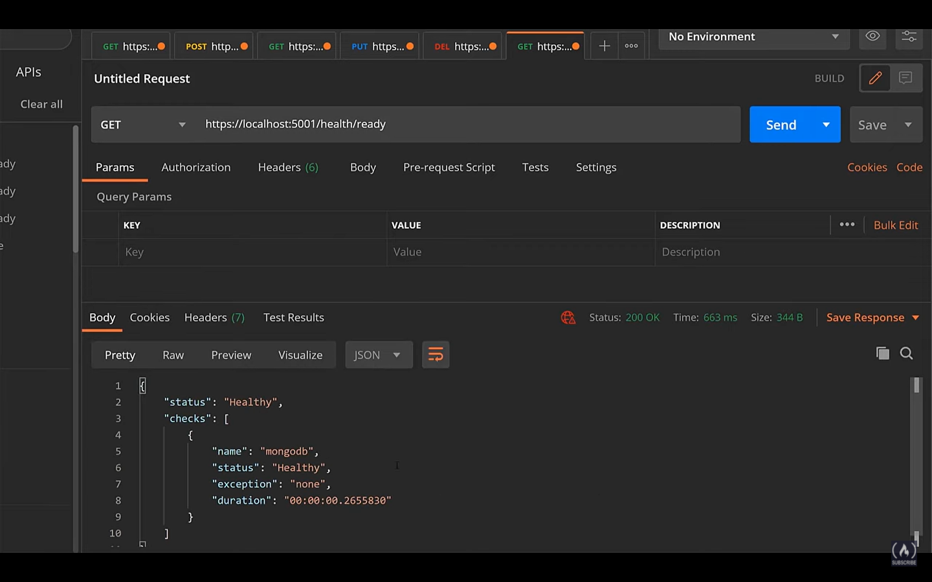

In case of unhealthy endpoint

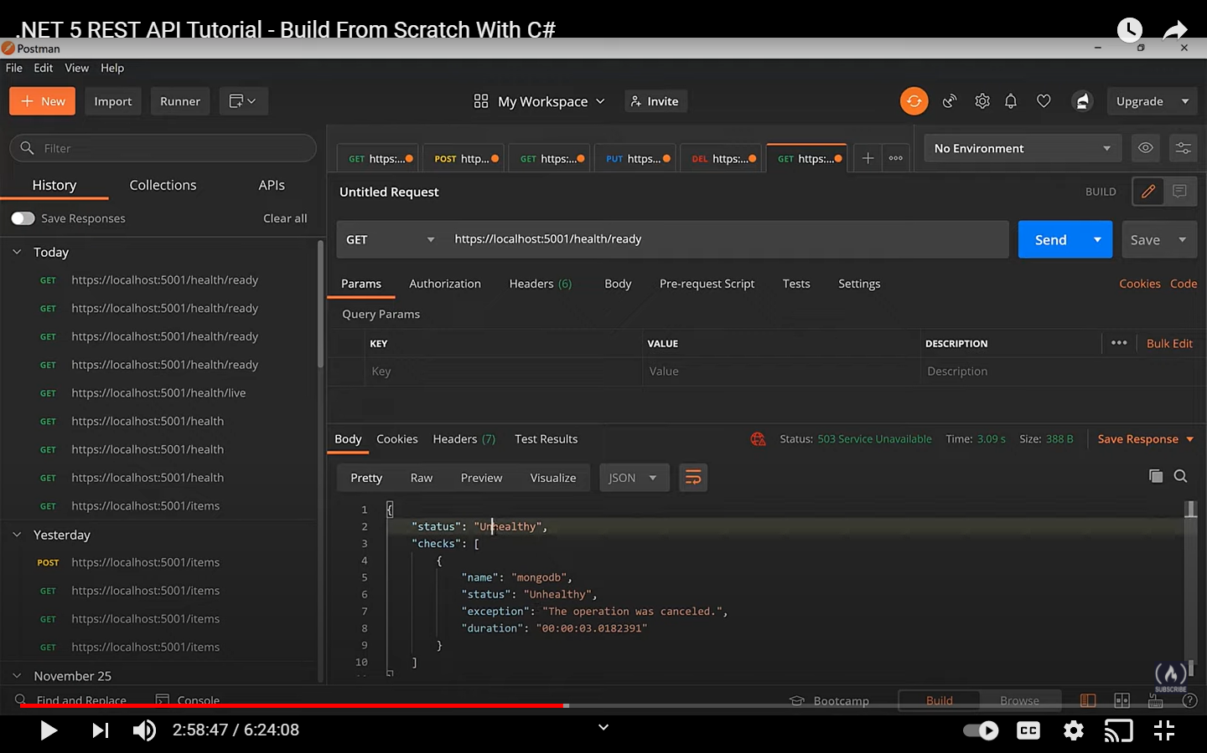

Only the mongodb endpoint is not health that’s what it is showing

Below opensource project has various healthchecks like the mongodb one that we used

https://github.com/Xabaril/AspNetCore.Diagnostics.HealthChecks

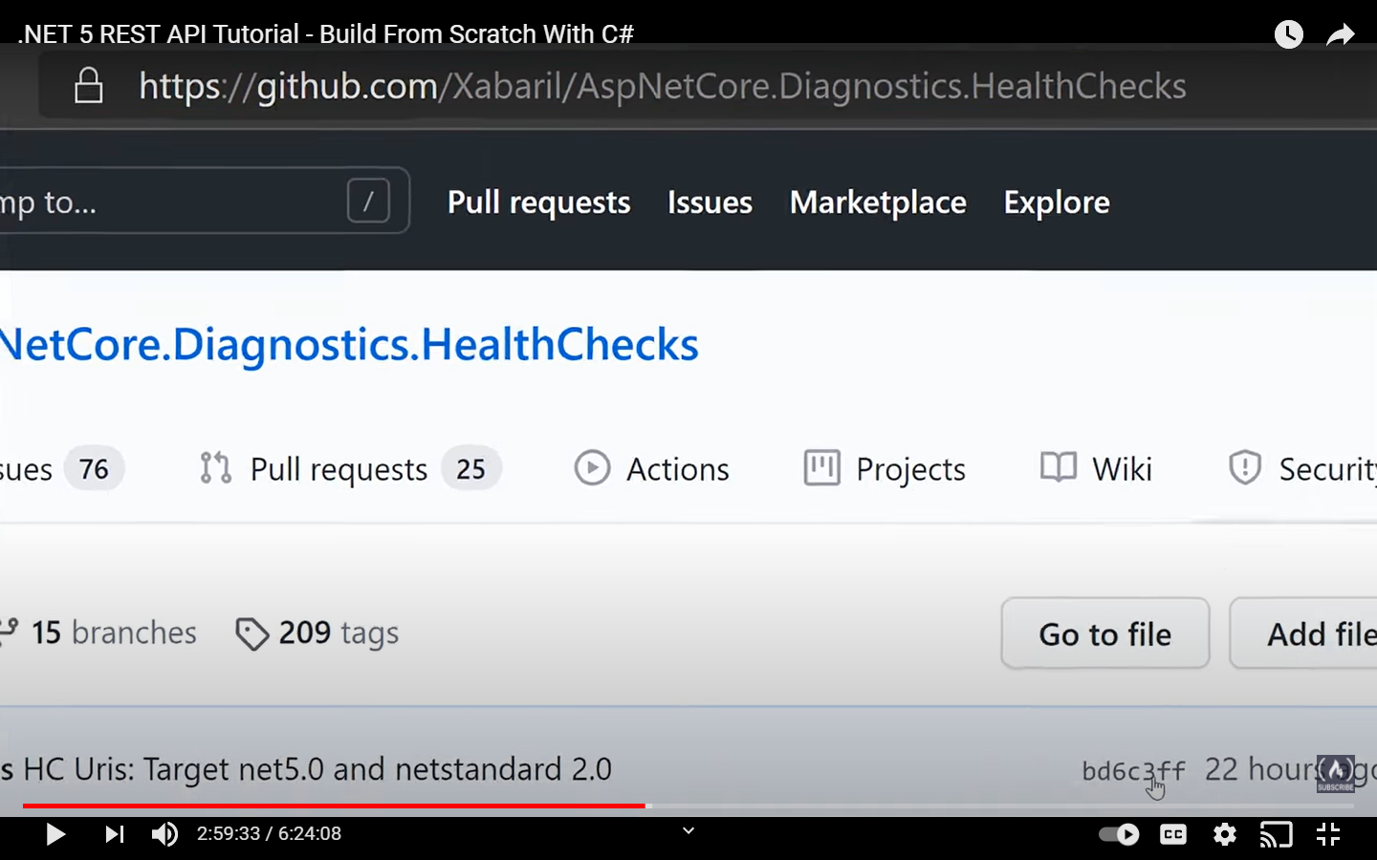

You can even enable the health check ui’s as well

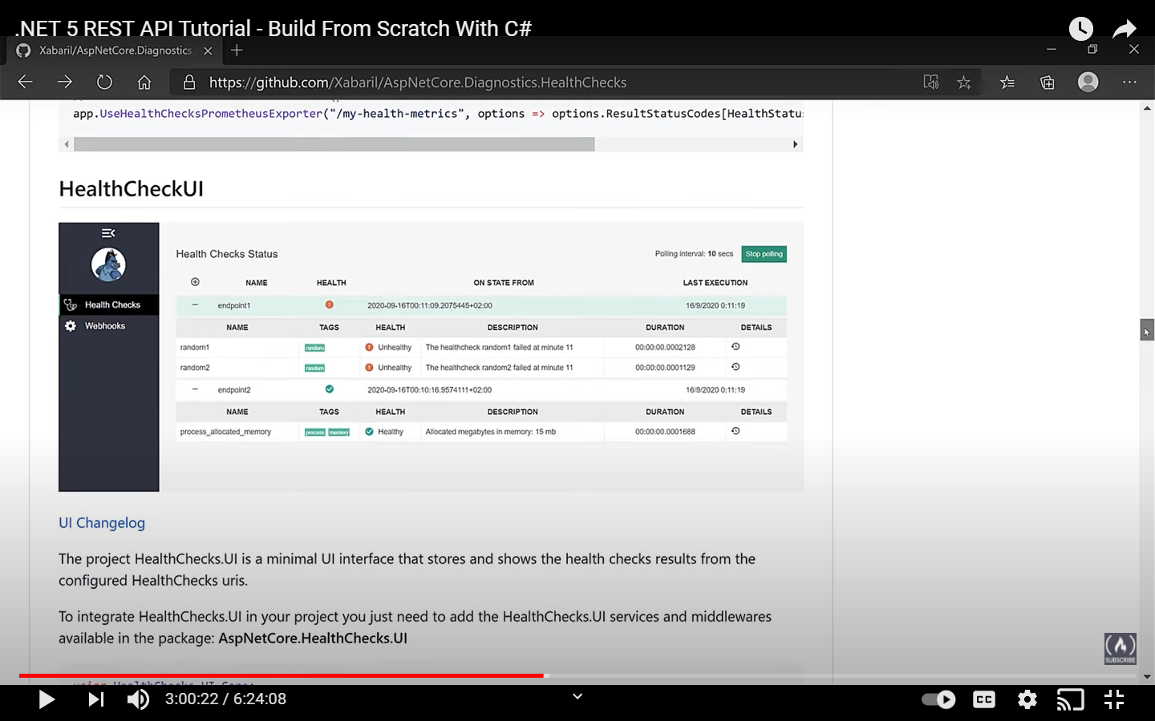

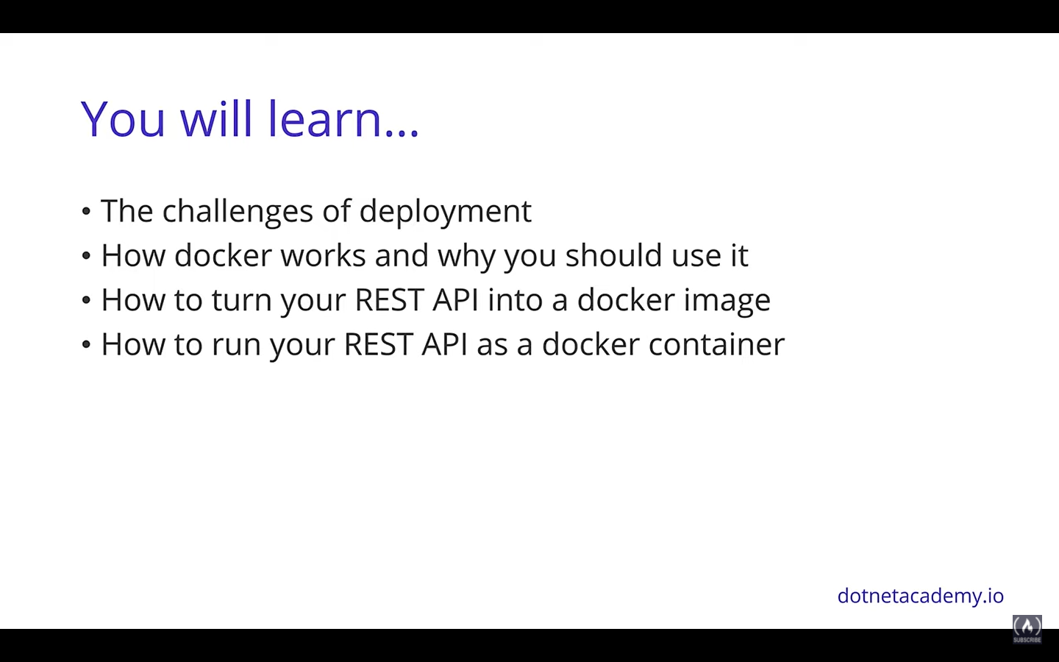

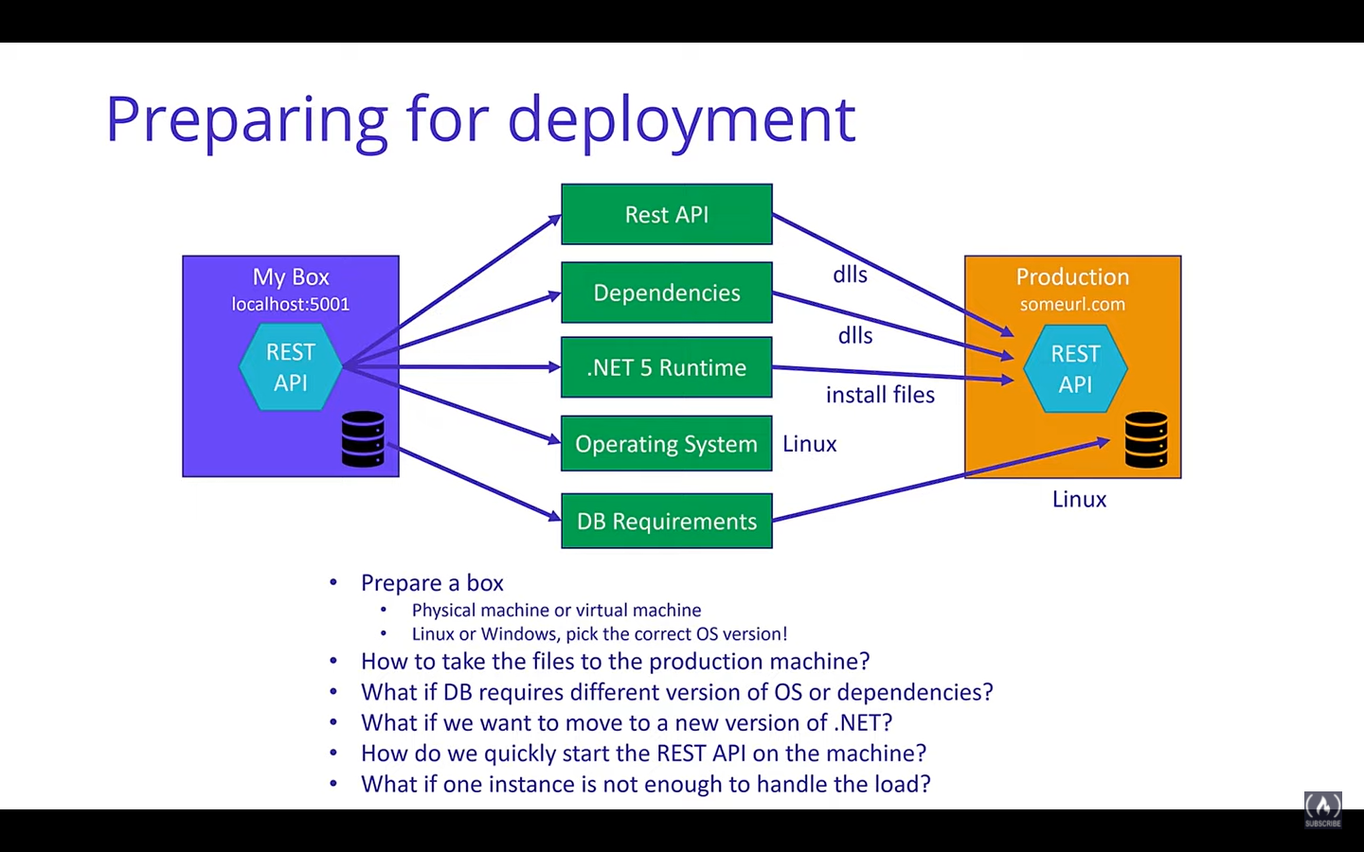

Docker engine is a process that is running in your local system that will take the dockerfile and create the docker image. IN the target system also we need the docker engine that will help in running the container.

Caching is also there in Docker containers. Since we do not have to boot the OS everyt time after the first install of the container the containers are booted fast.

As long as you have docker engine the containers can run on that machine

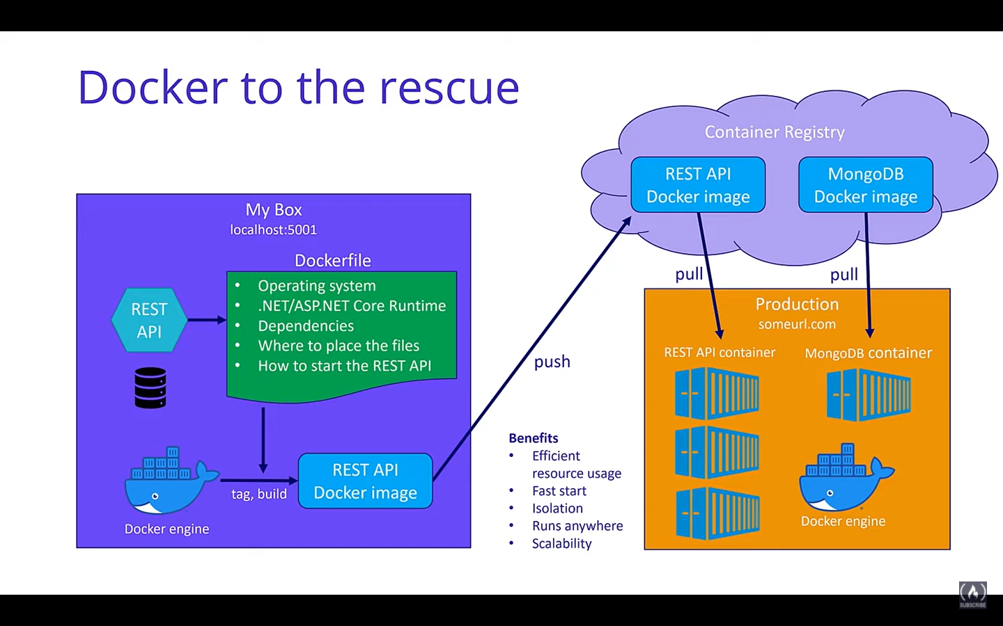

Just for the purpose of this training we are disabling the https redirection

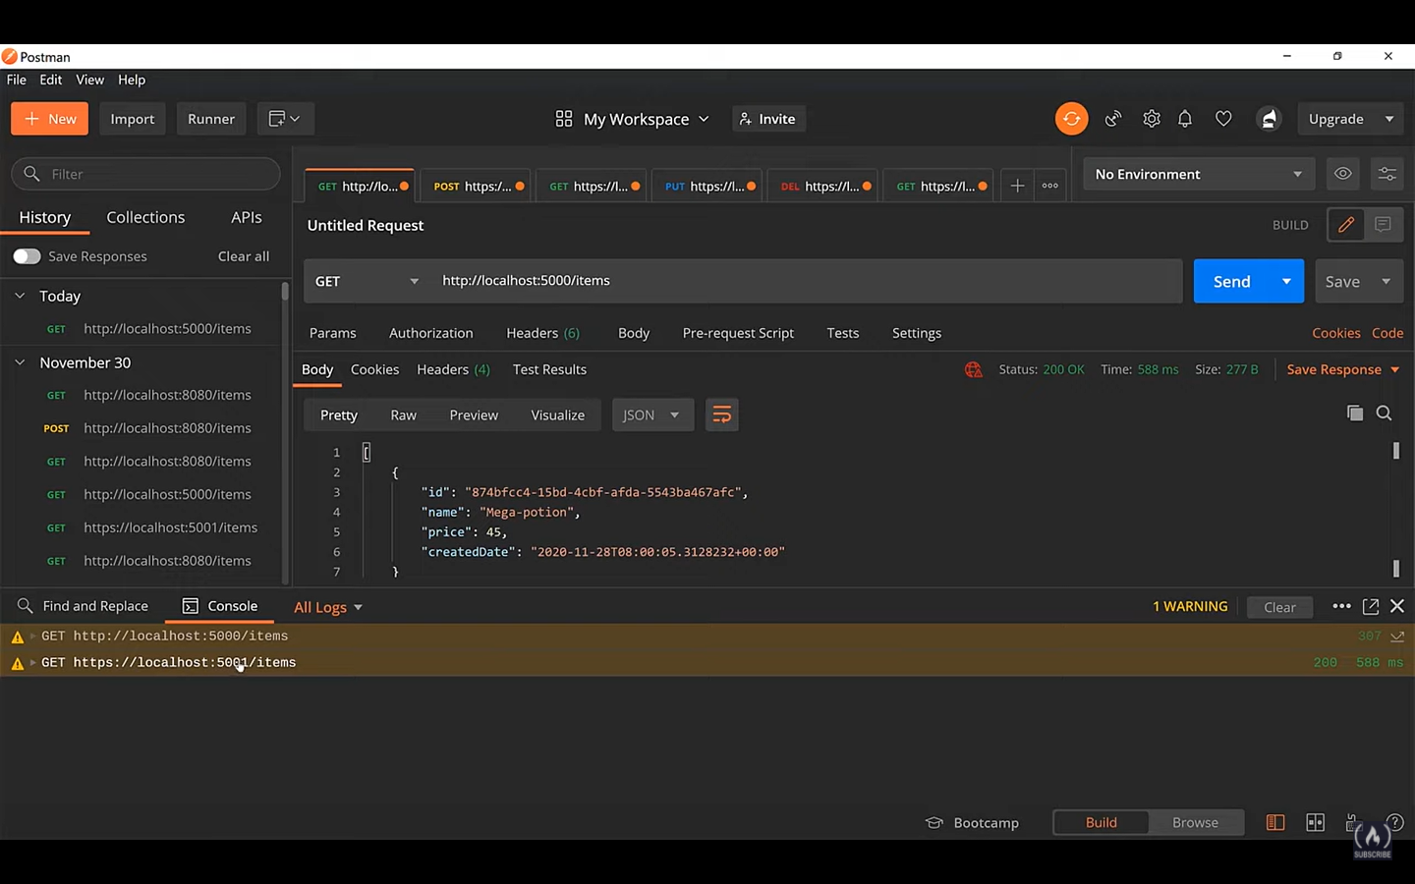

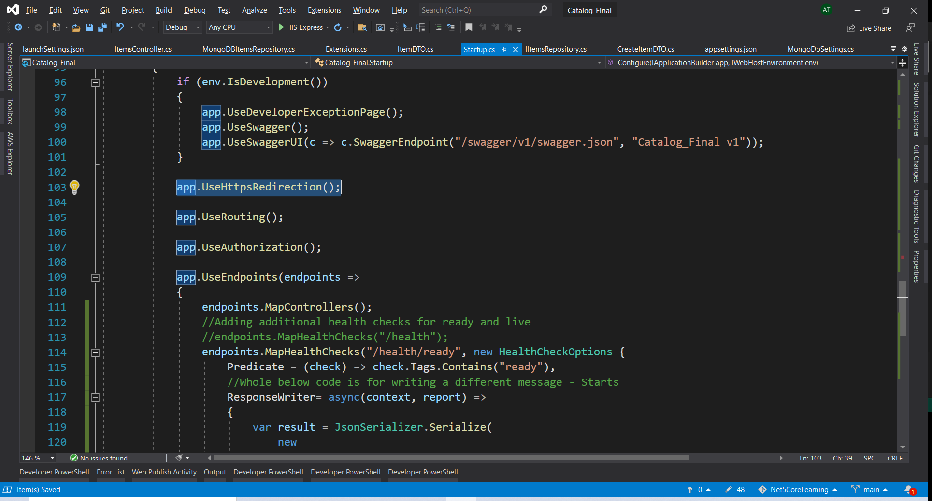

In case of the VS Code you can install the docker extension

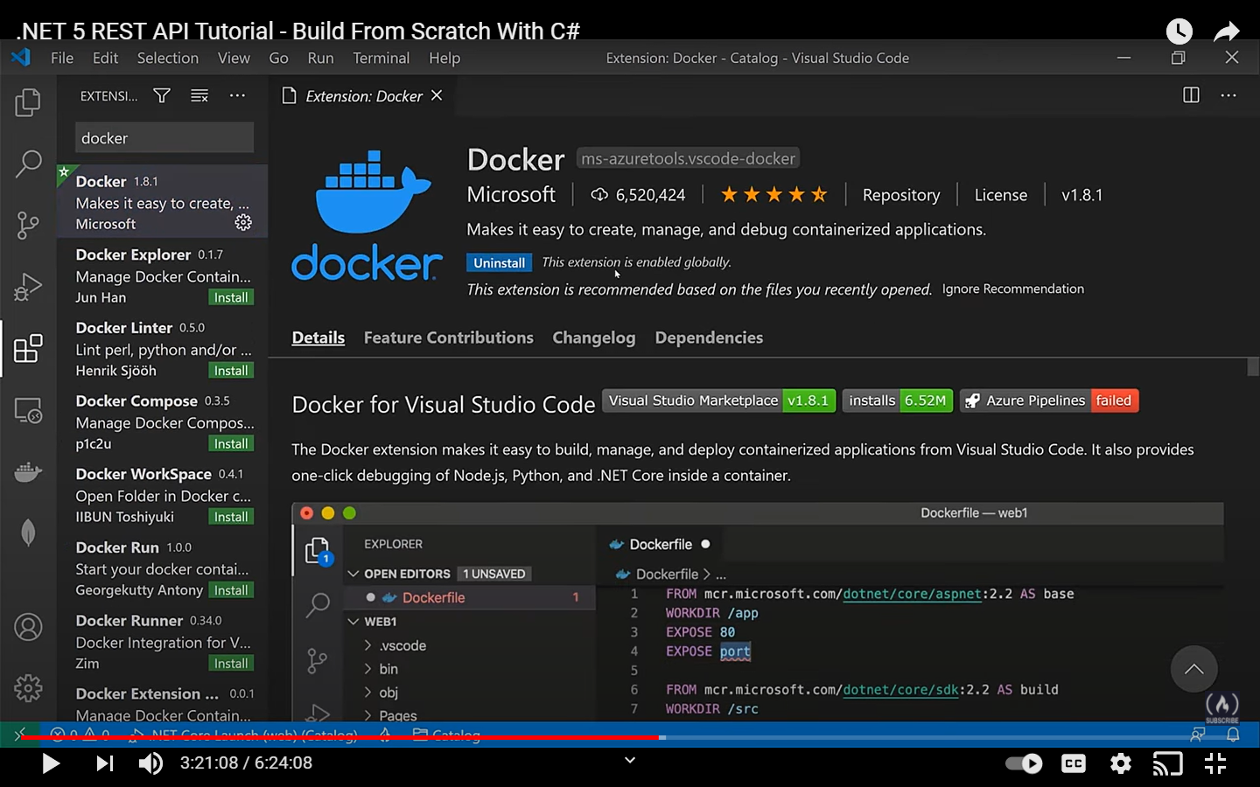

Then go to command palette

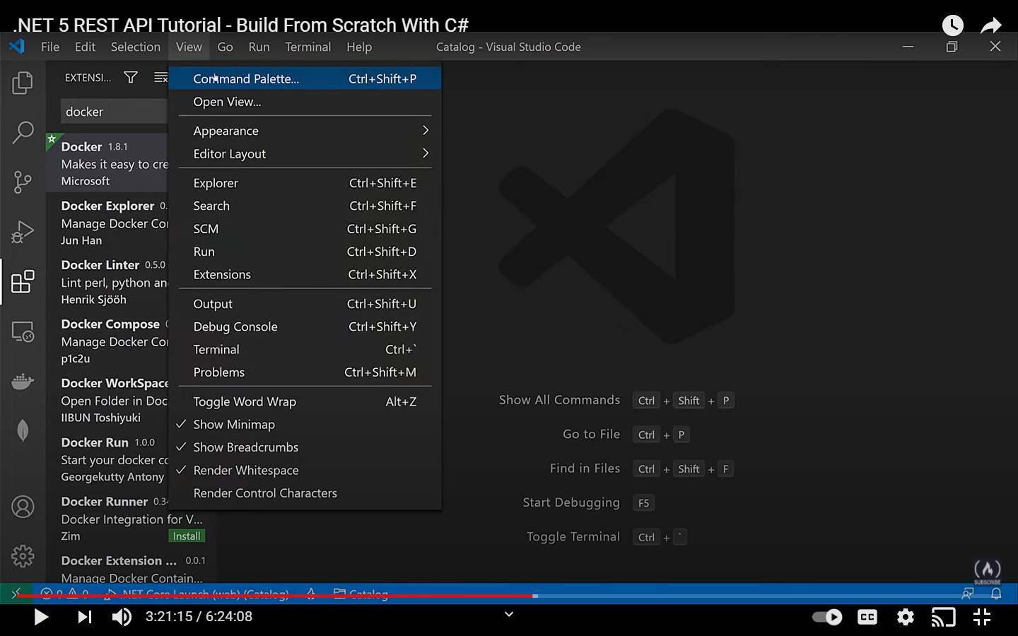

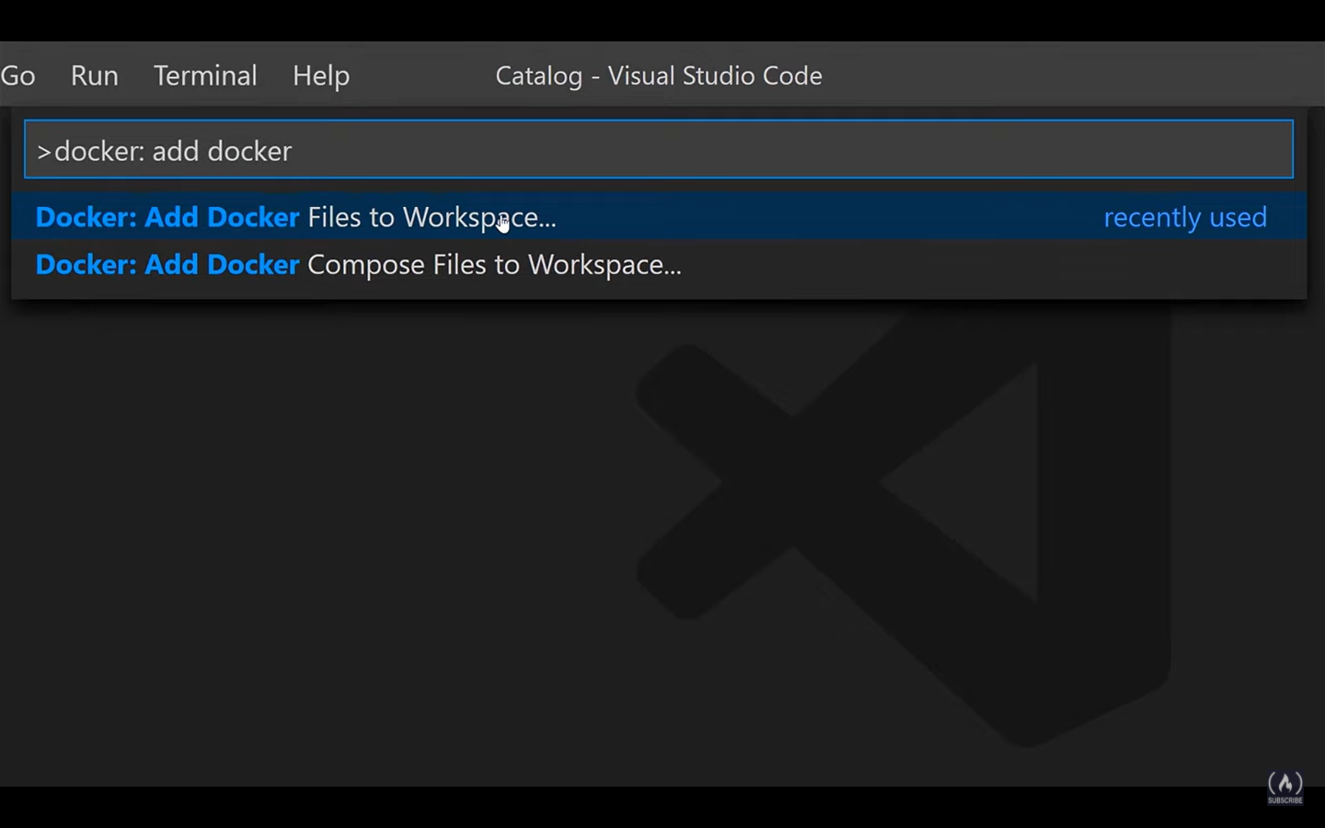

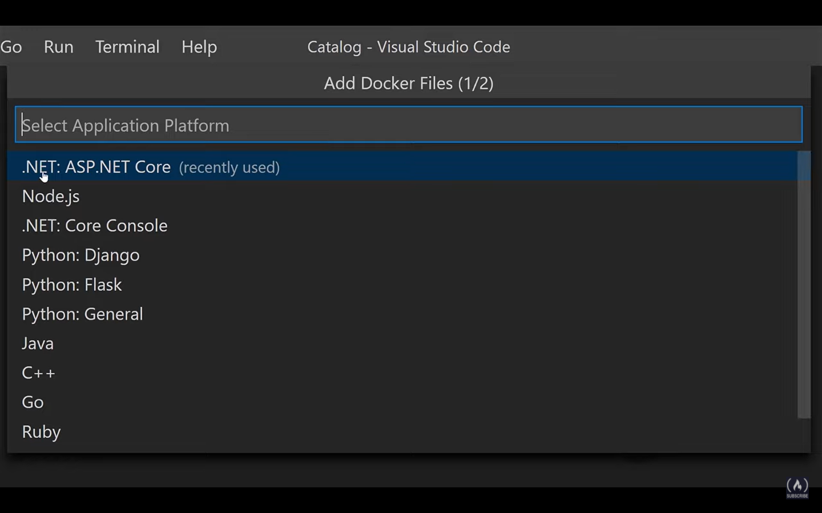

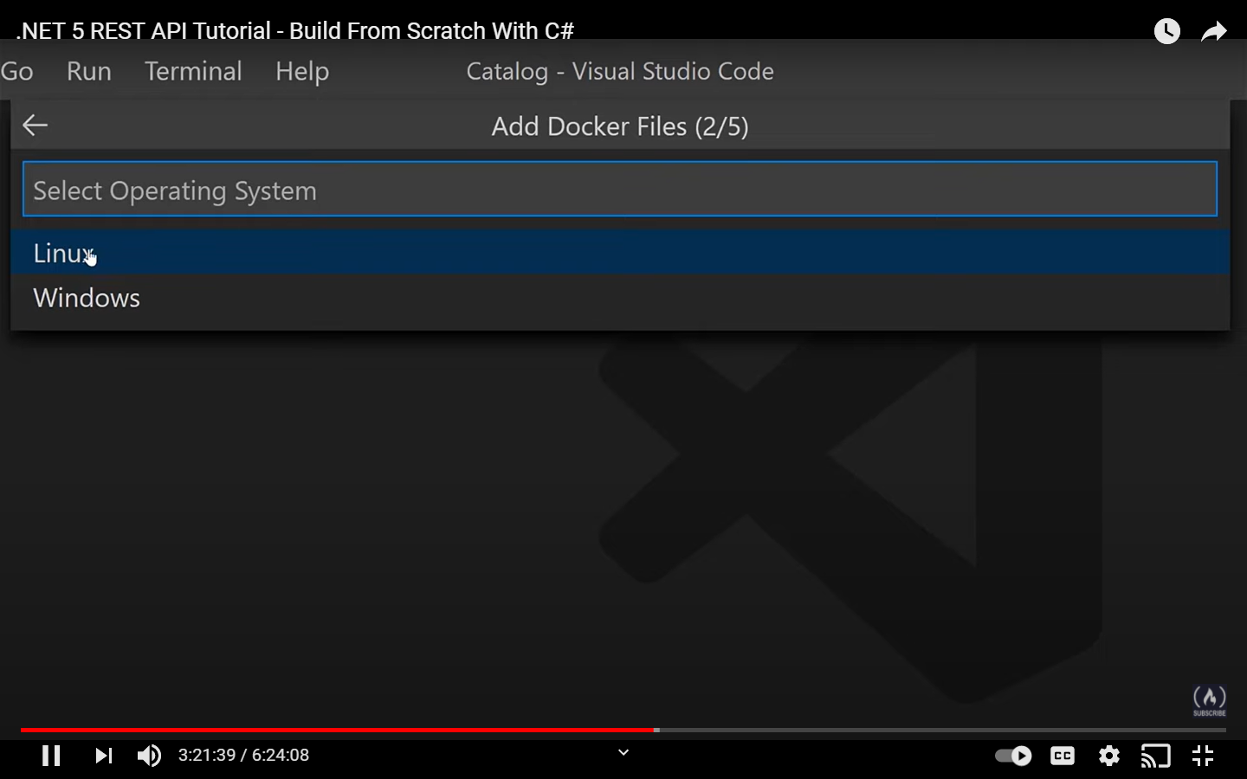

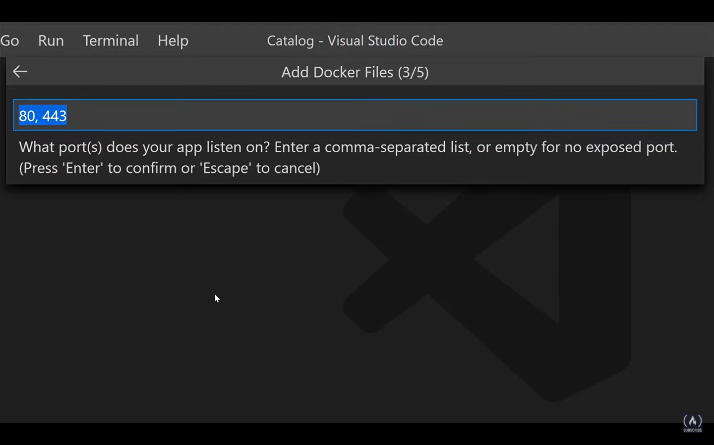

We will select port 80… for this tutorial we can ignore 443

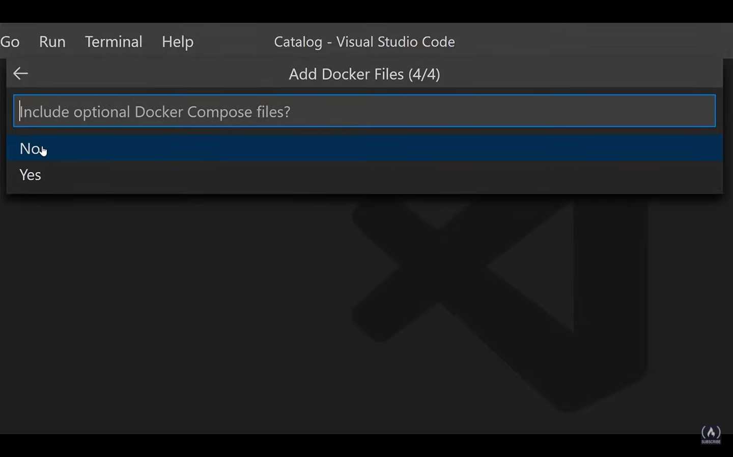

Just select No for this tutorial

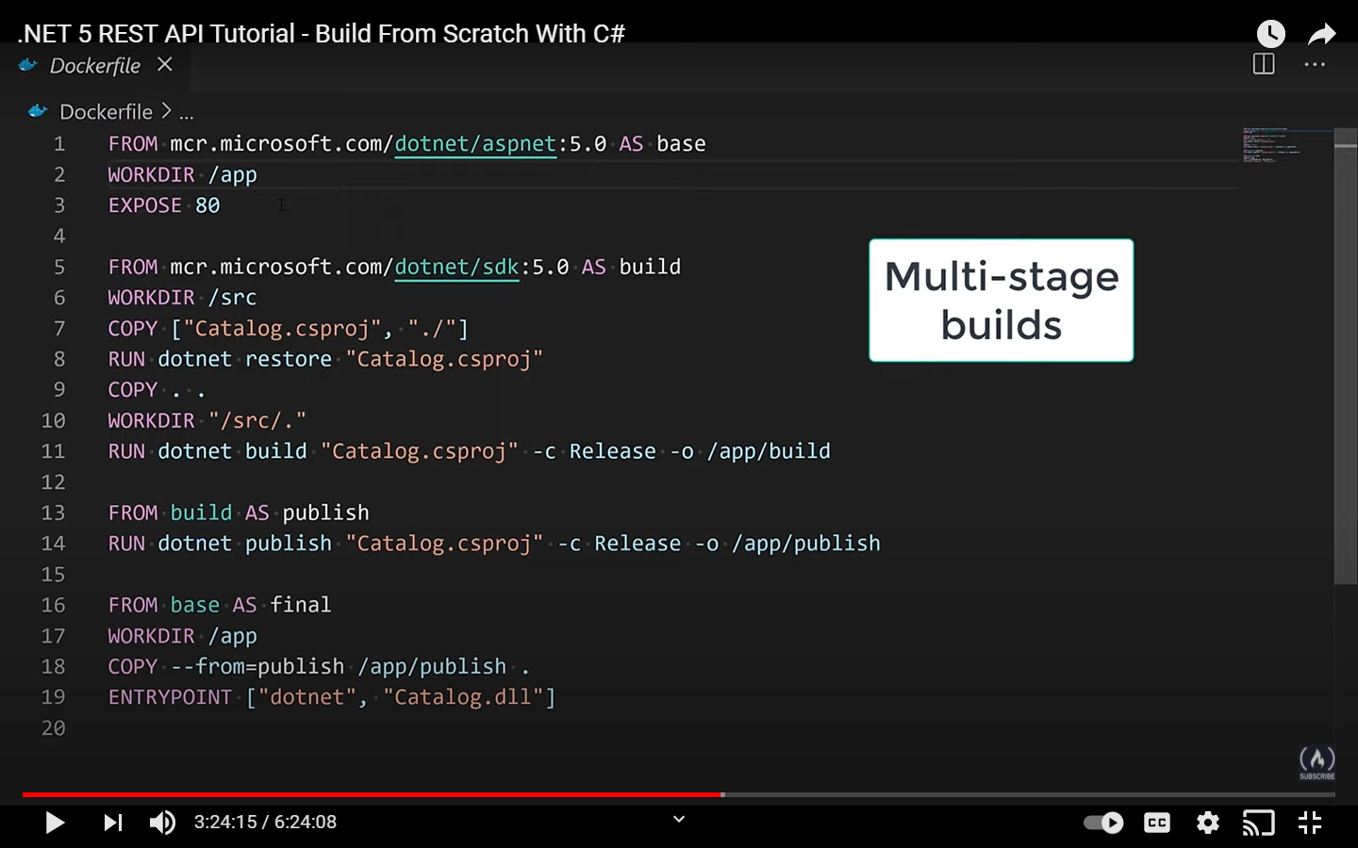

This is a multi stage builds. In our file also we have the initial stage base for aspnet5.0

Expose 80 – this is just a documentation and a convention as well. But port opening in Dockers are done in a different way

Dotnet restore on the csproj will bring all the nuget packages that are used by our app i.e. that are mentioned in the csproj file

COPY . . – copying all..

Here the multiple stages are base, build, publish and final

Line 13 goes from a build stage to publish the code

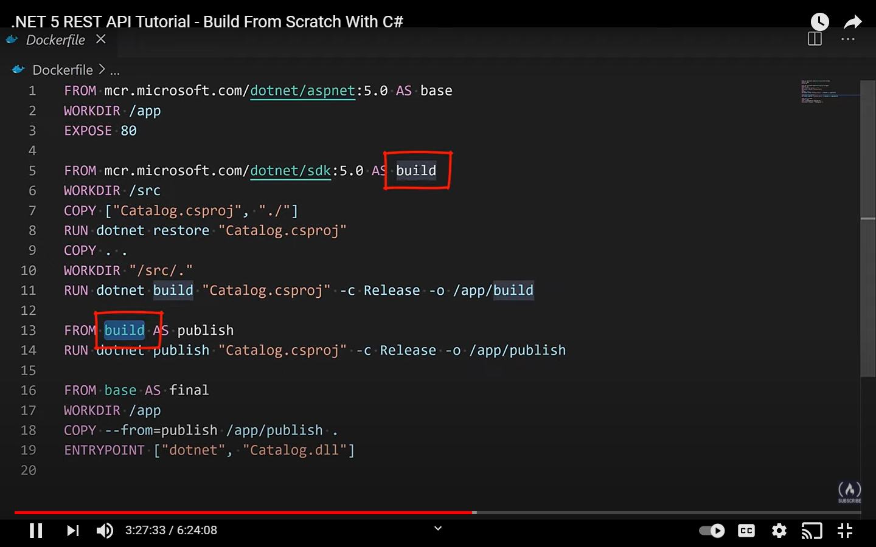

After updating

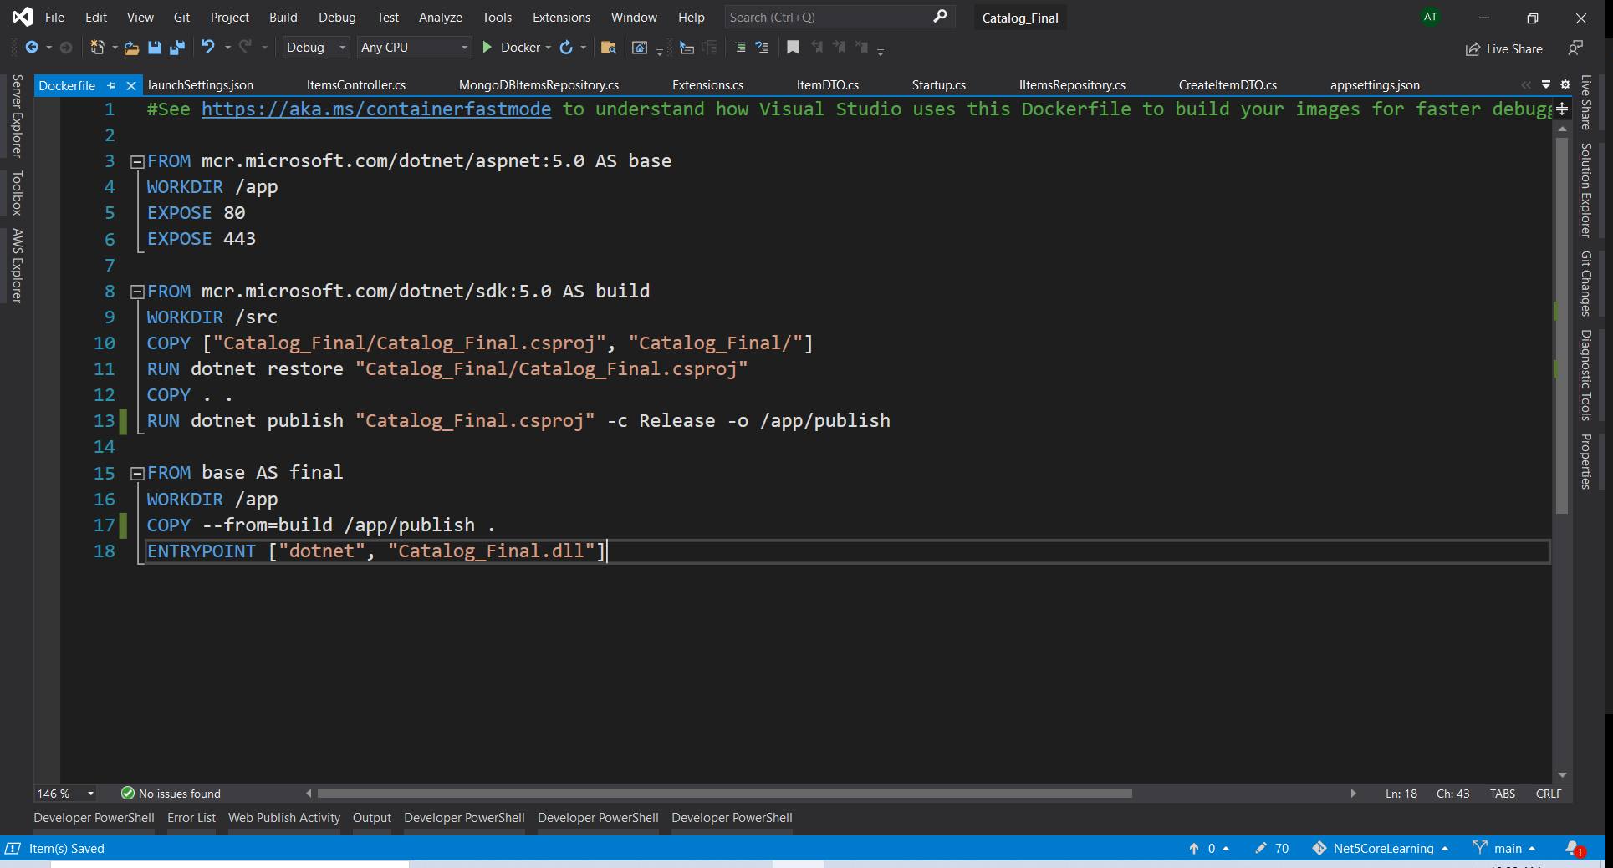

Line 18 – how to start the rest api

Dockerignore – files that will be ignored from the image

Docker build -t catalog:v1 .

Catalog is the name and V1 is the tag that we are giving

In the last we have specified . that means the current directory

Final

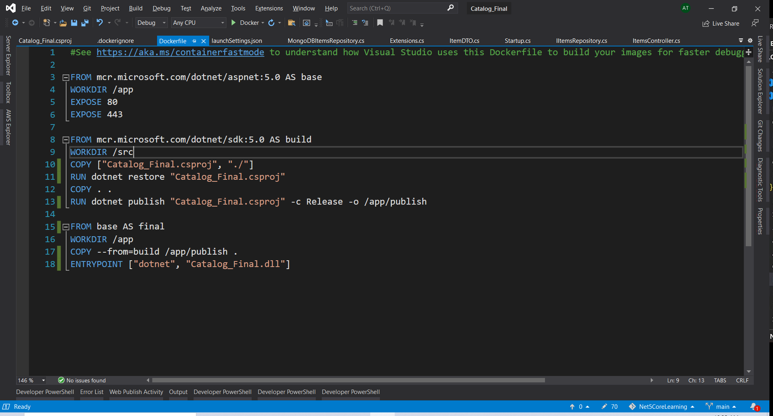

Here we have the app container and the mongo db container. We have to make sure that both the containers talk to each other and the way we can do this is by using docker network

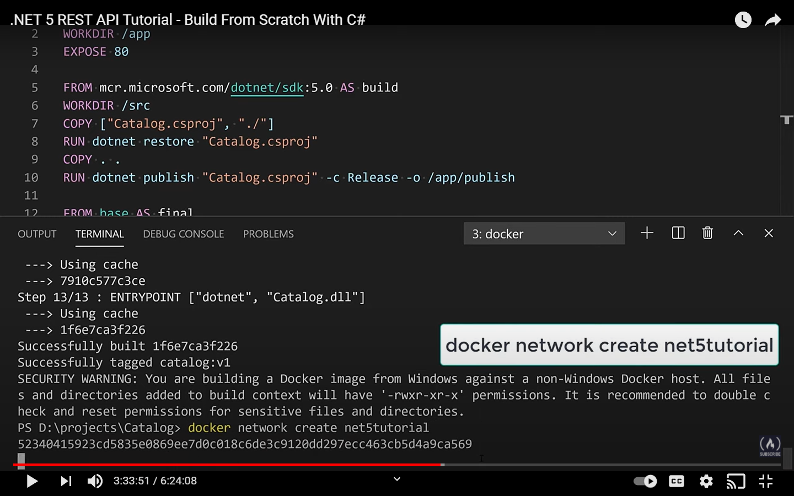

Below command to see the existing networks

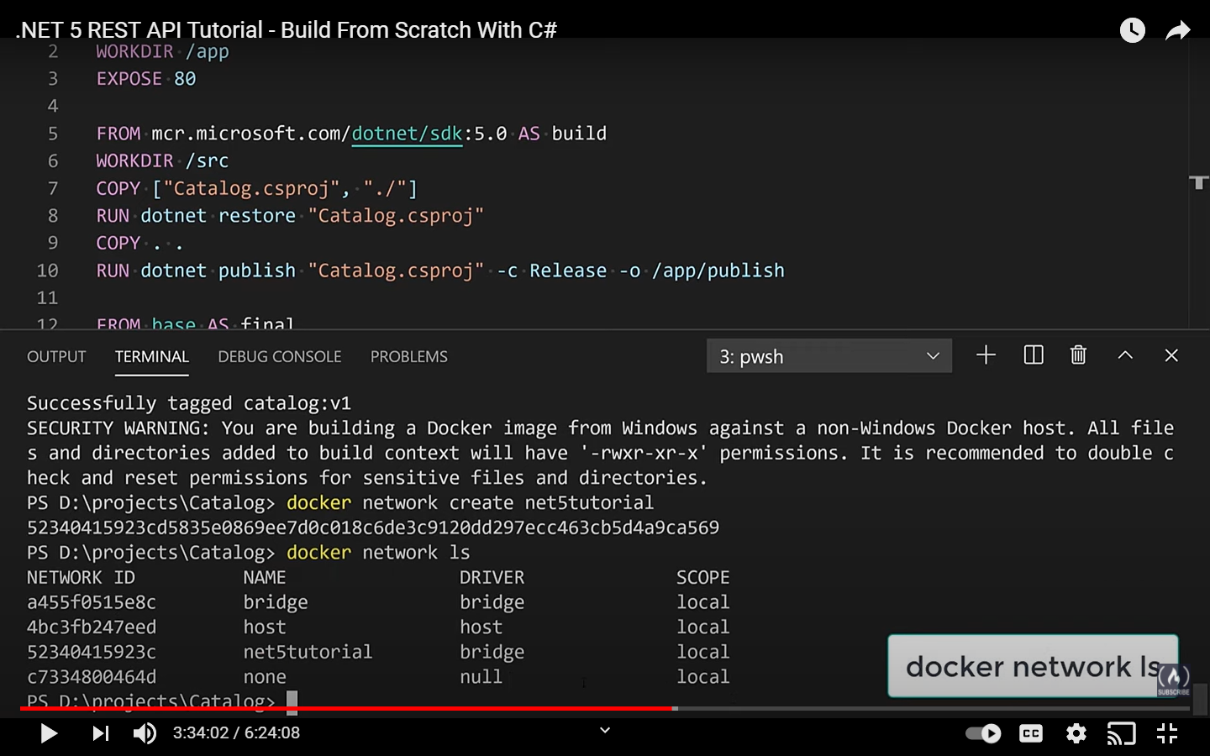

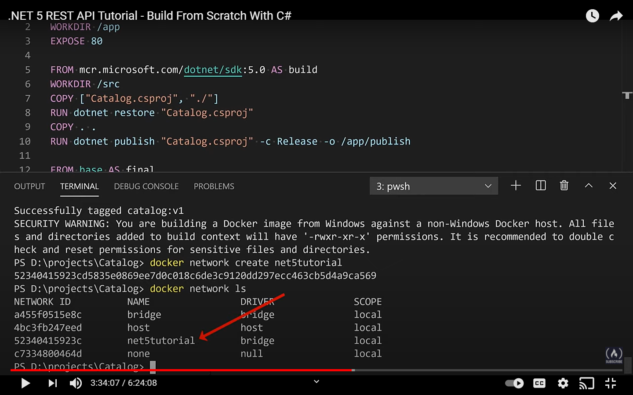docker stop mongo

This is the command for stopping any container

Now lets create the container and add that to the network as well

**docker run -d --rm --name mongo -p 27017:27017 -v mongodbdata:/data/db -e MONGO_INITDB_ROOT_USERNAME=mongoadmin -e MONGO_INITDB_ROOT_PASSWORD=Pass#word1 --network=net5tutorial mongo**

we have already created the image for the catalog and you can find that with docker images

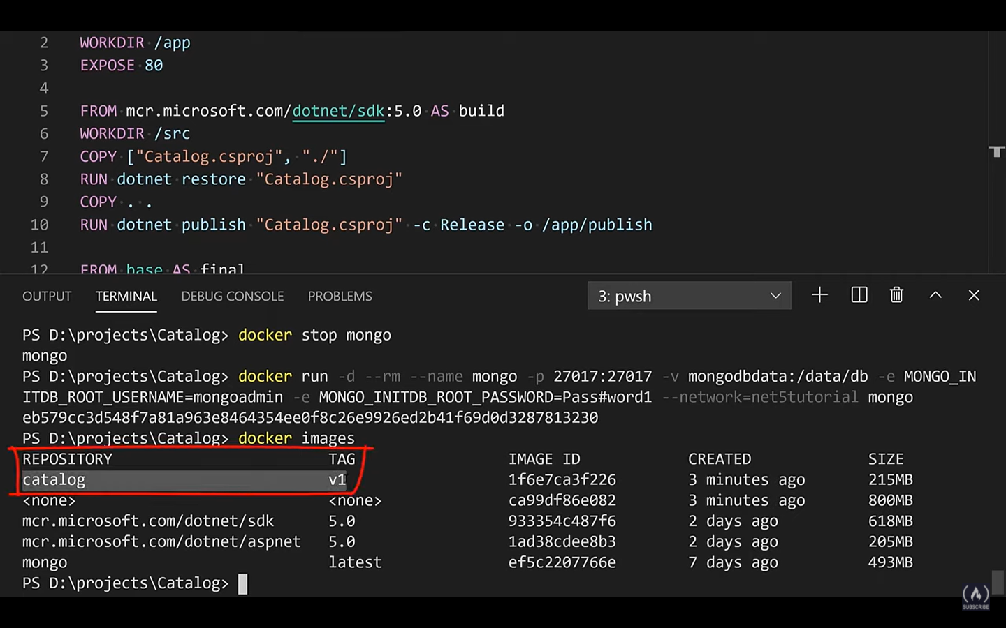

On the docker image the asp.net run time will always run on port 80

In docker run command **-it** means interactive so that whatever is happening we get the output

Now that mongo db is in a container we cannot talk just with localhost. So, we have to override some of the parameters and for that we do not have to update the json file but we can just add some environment variables and that will overrides those values.

So we have to override host and password

**docker run -it --rm -p 8080:80 -e MongoDbSettings:Host=mongo -e MongoDbSettings:Password=Pass#word1 --network=net5tutorial catalog:v1**

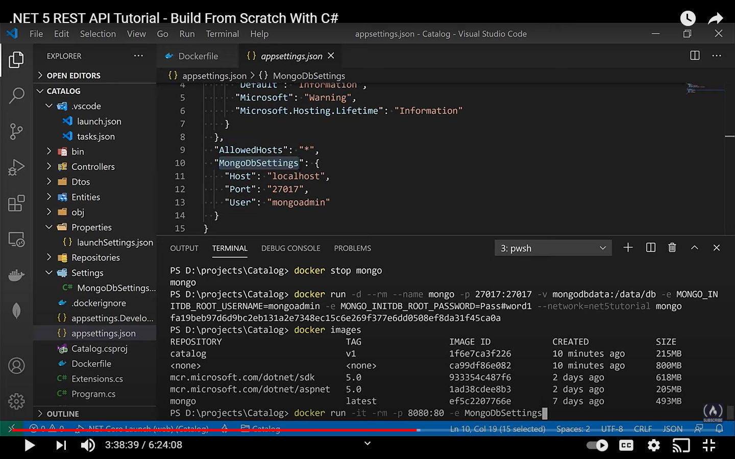

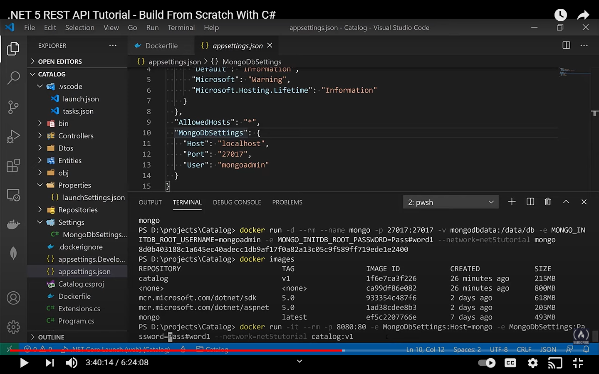

Last option i.e. catalog:v1 is the image name and the tag

When you run the hosted env changes from dev to production

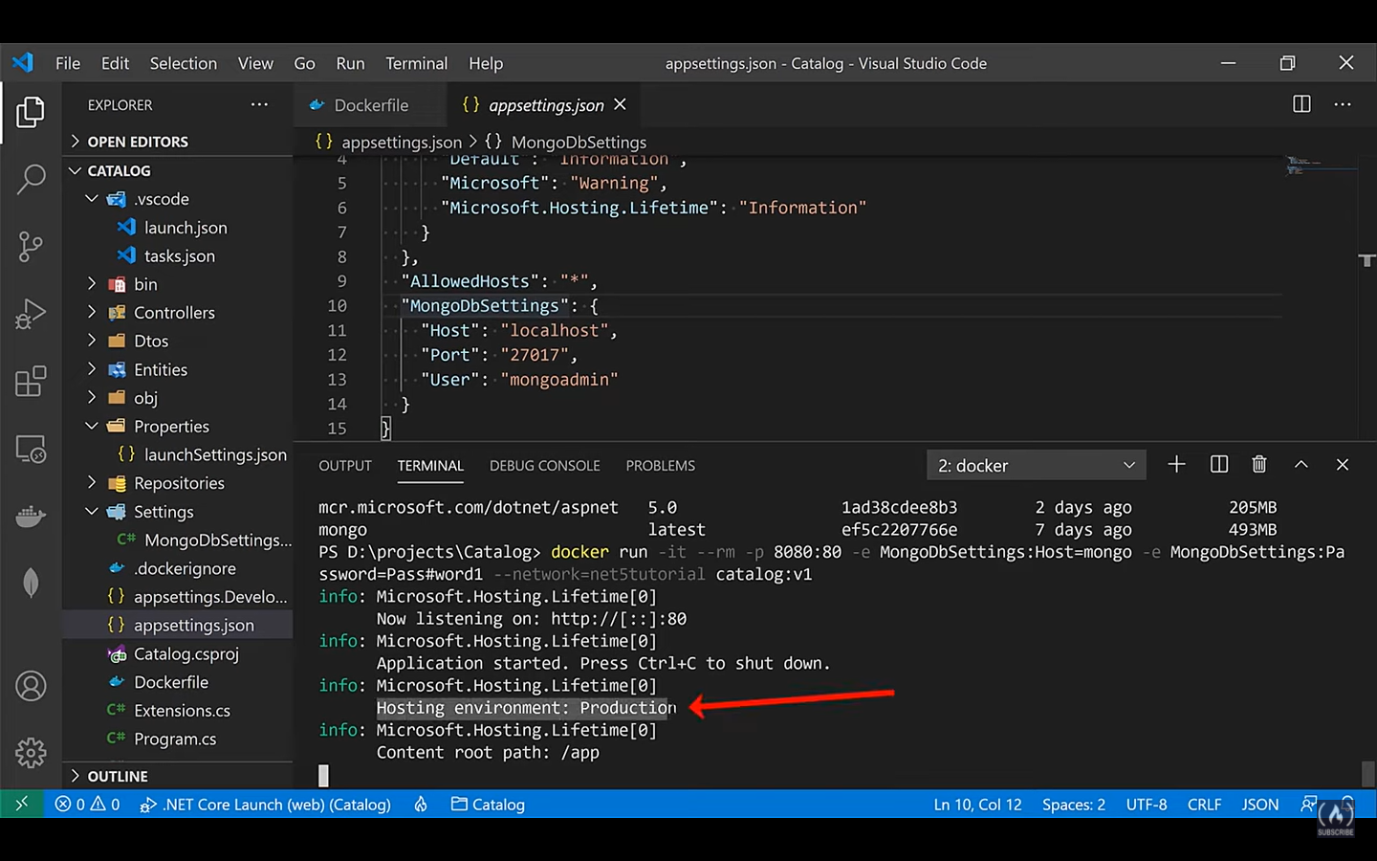

And now we can reach on port 8080 and http

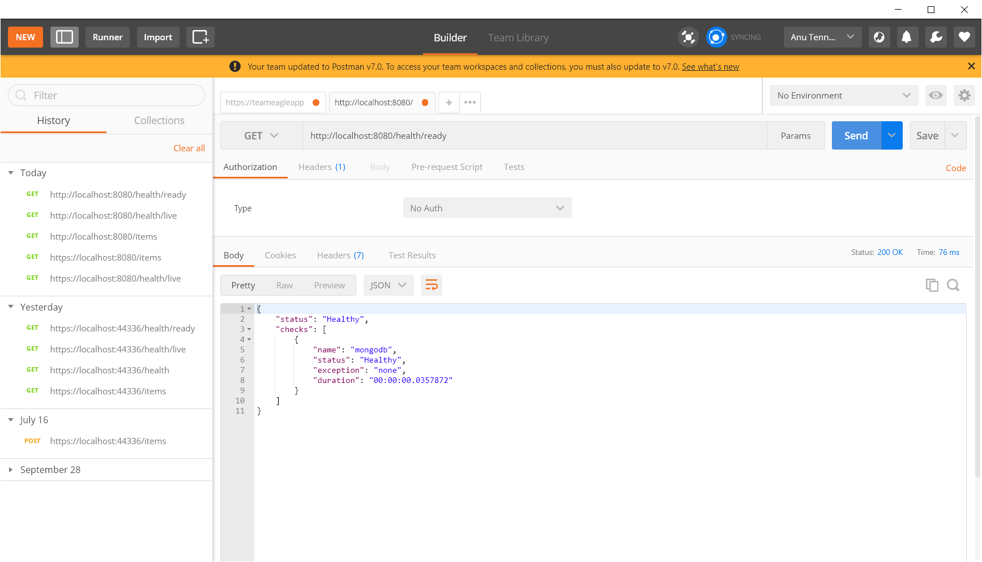

307 – redirect happening

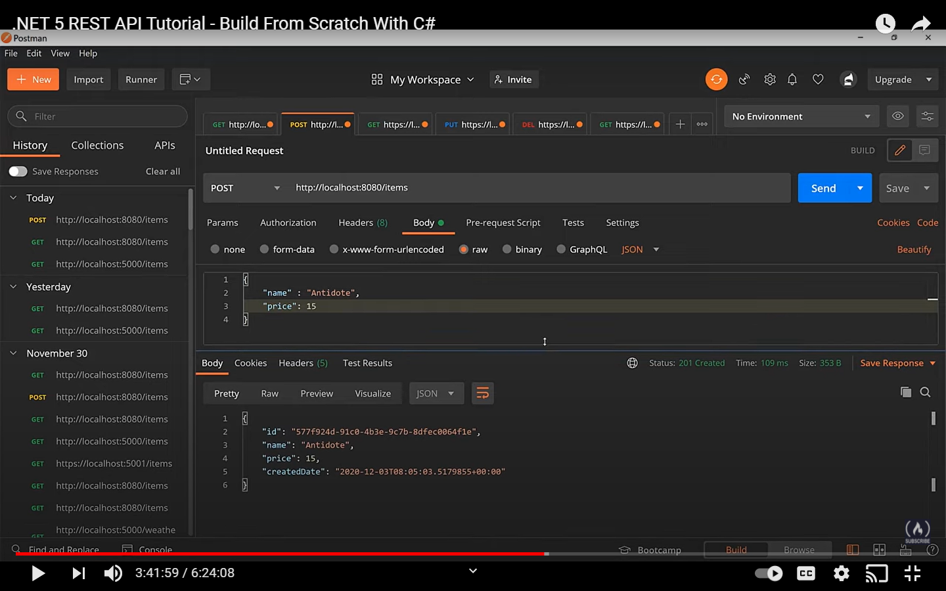

Docker image can be shared as well… that’s the beauty

We will be sharing it to docker hub

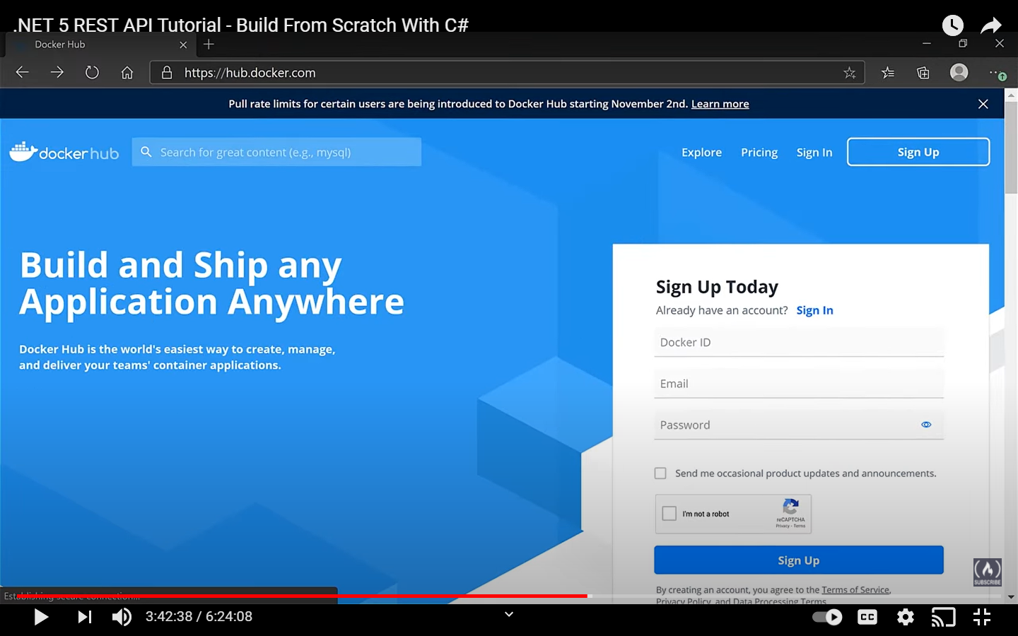

**Docker login**

This is the command to login to docker hub and it will ask for the username and password

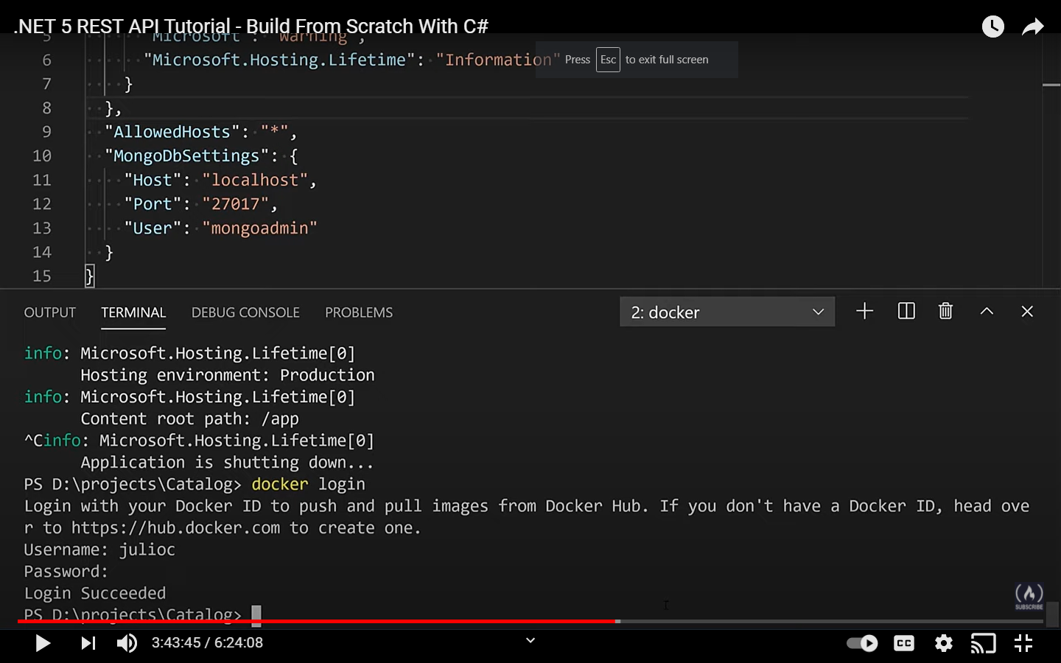

Docker images

This will show all the images

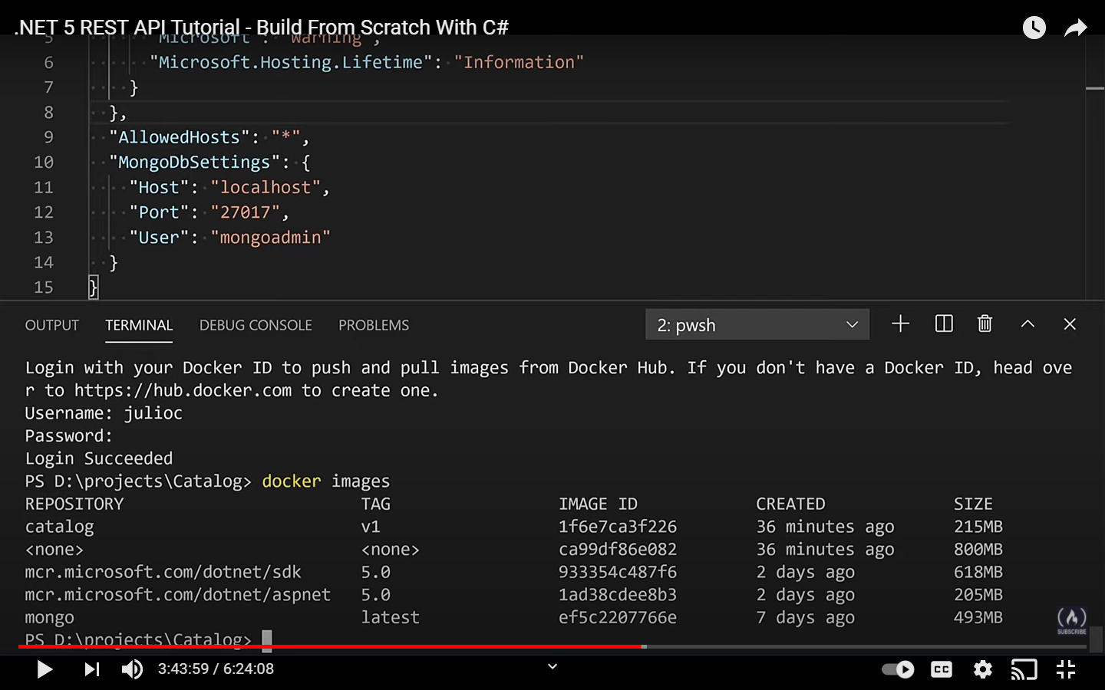

For pushing the main thing that you need is to retag the image

**Docker tag catalog:v1 username/catalog:v1**

The highlighted part can be anything but for consistency you can keep it as catalog:v1

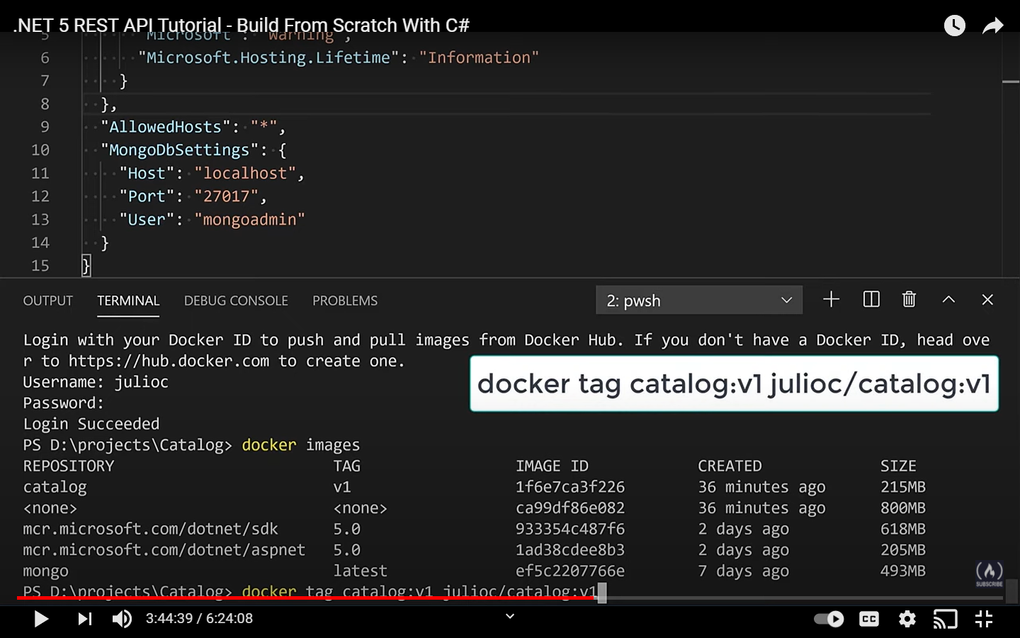

So if you do docker images again you will see a new repo with a new tag

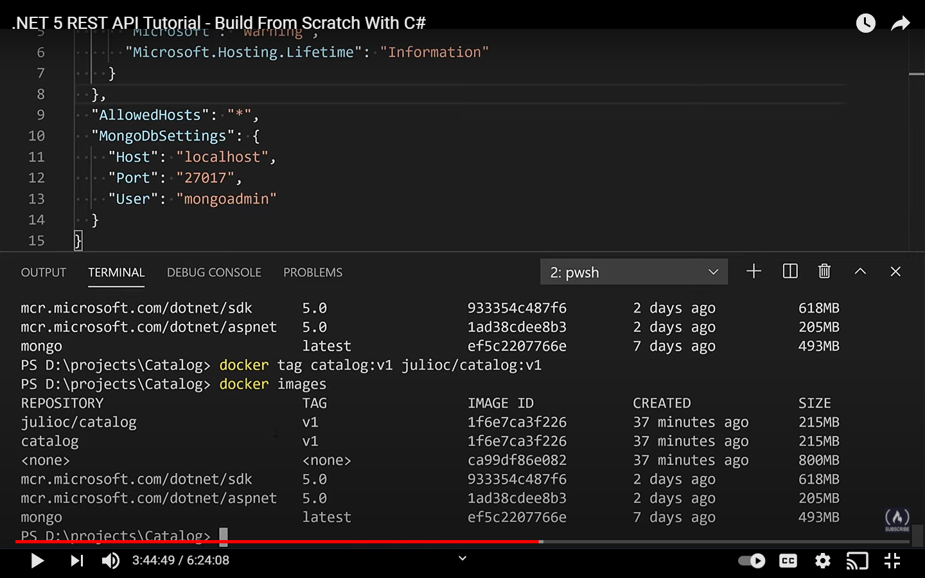

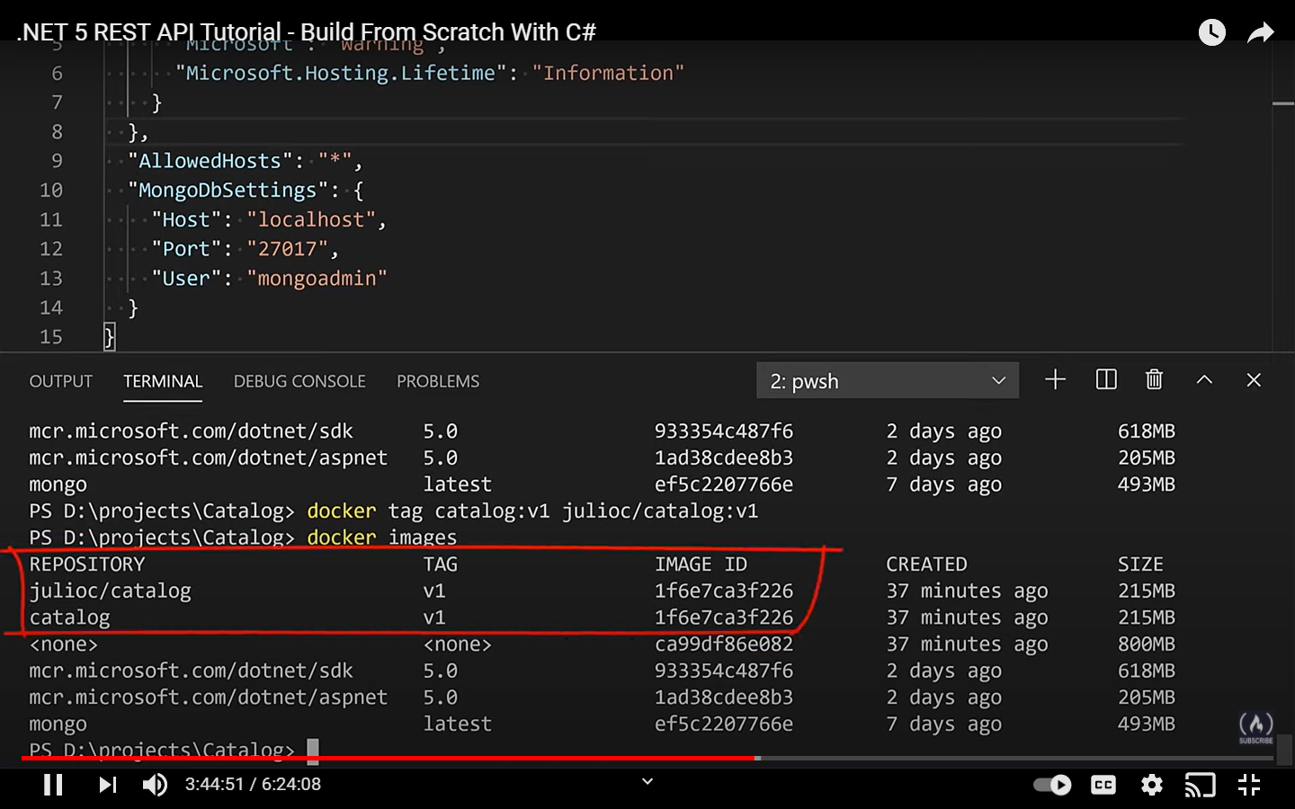

But you can see that the image id is same

Now you can push the new image

Docker push username/catalog:v1

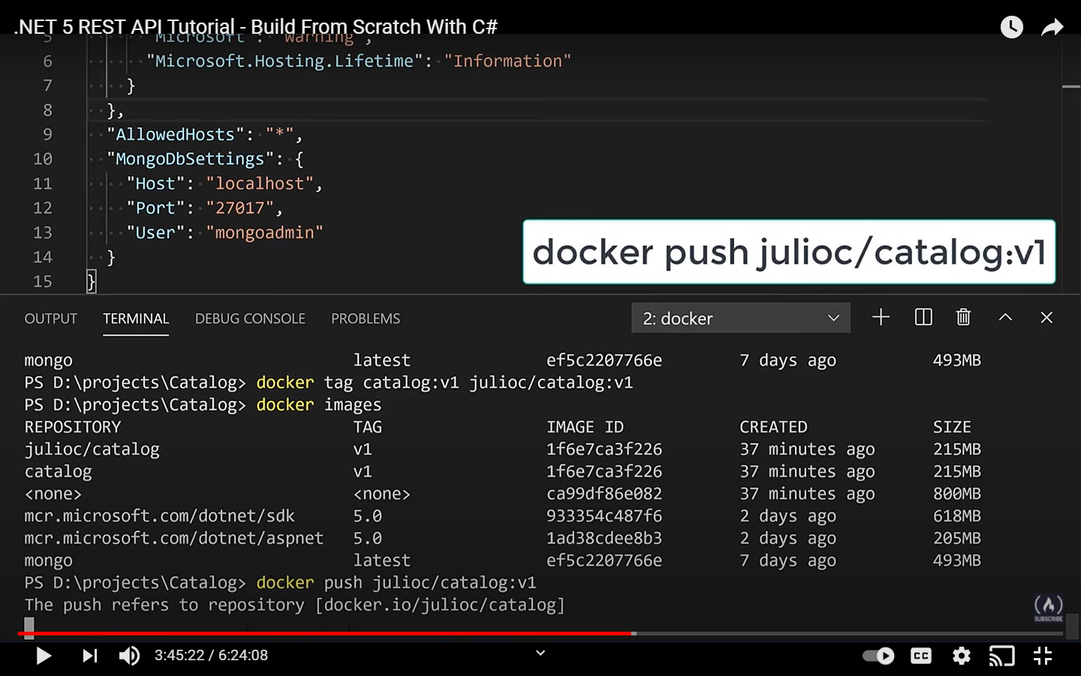

And this will push to docker hub

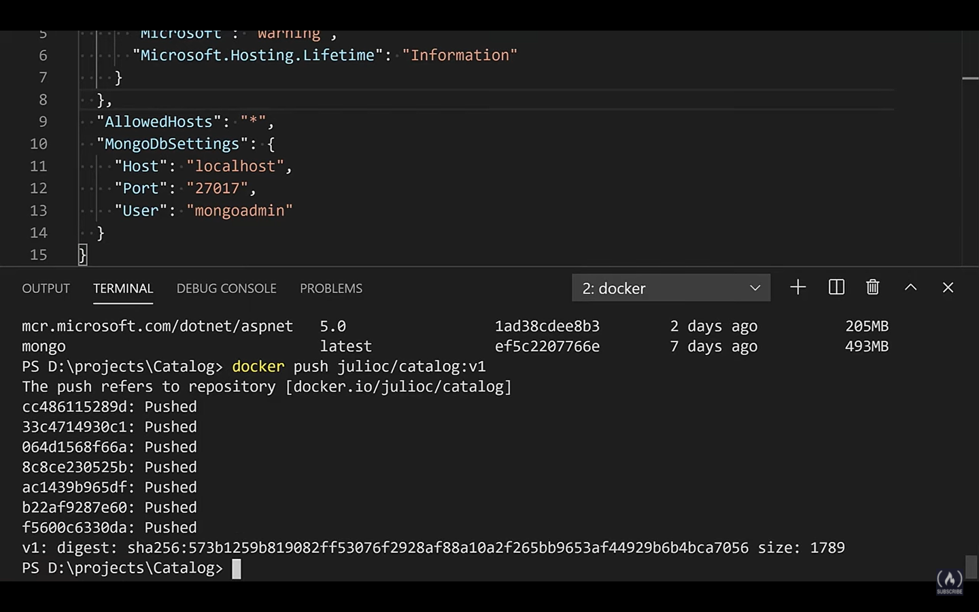

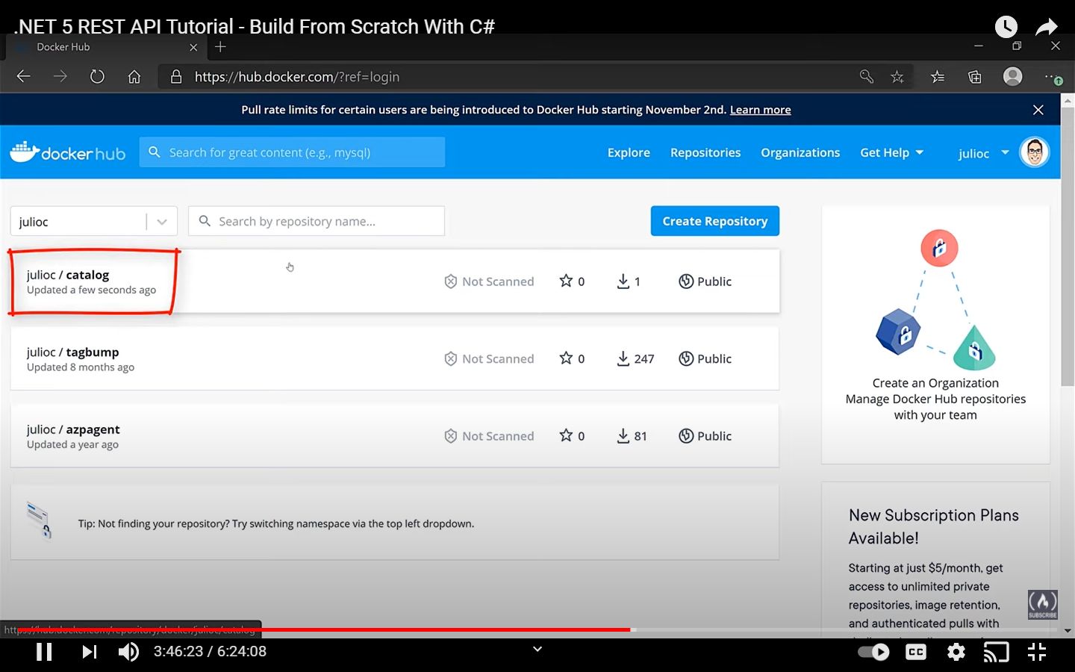

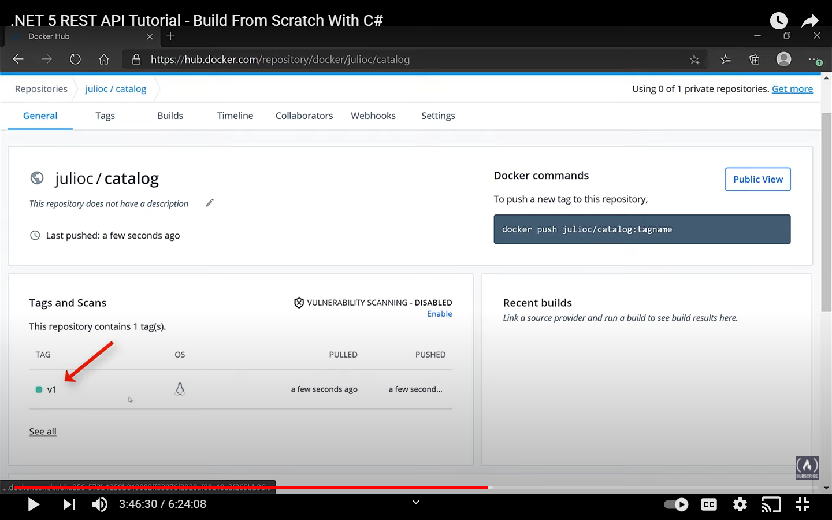

If we want to pull the image to a computer that does not have that image then we can do a docker pull

To remove images you have to do

Docker rmi catalog:v1

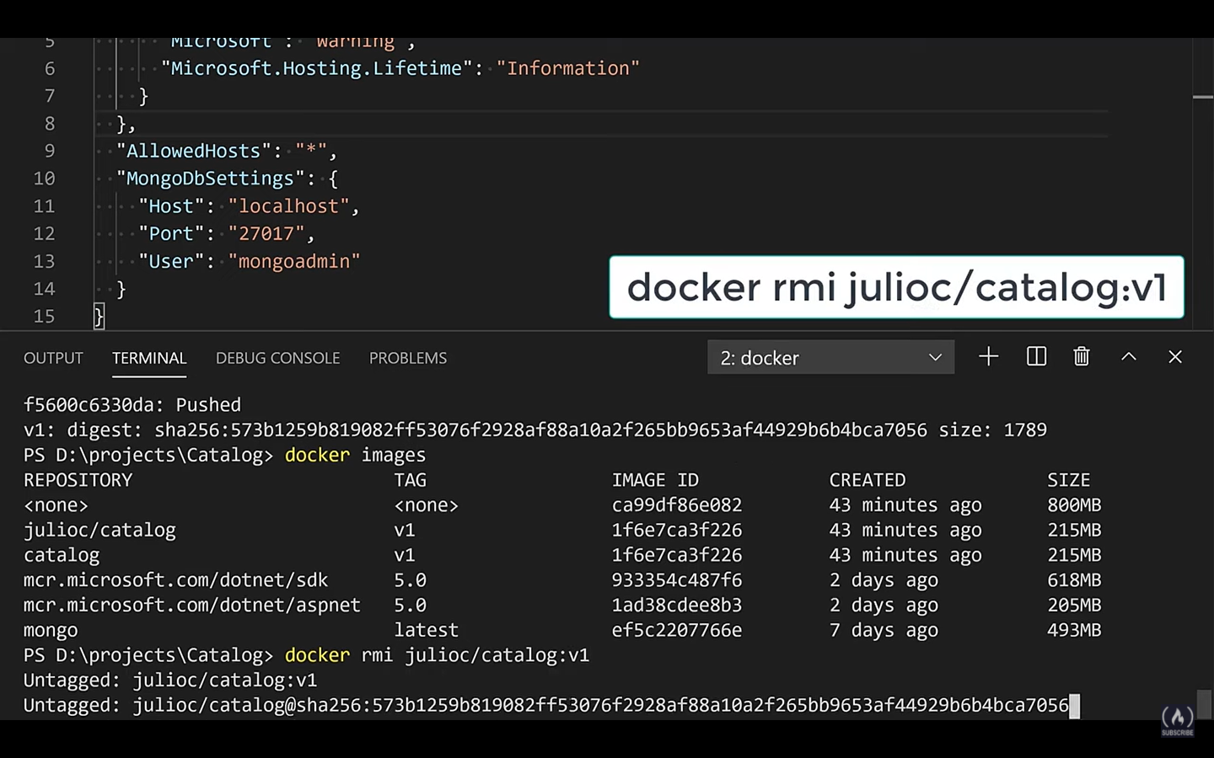

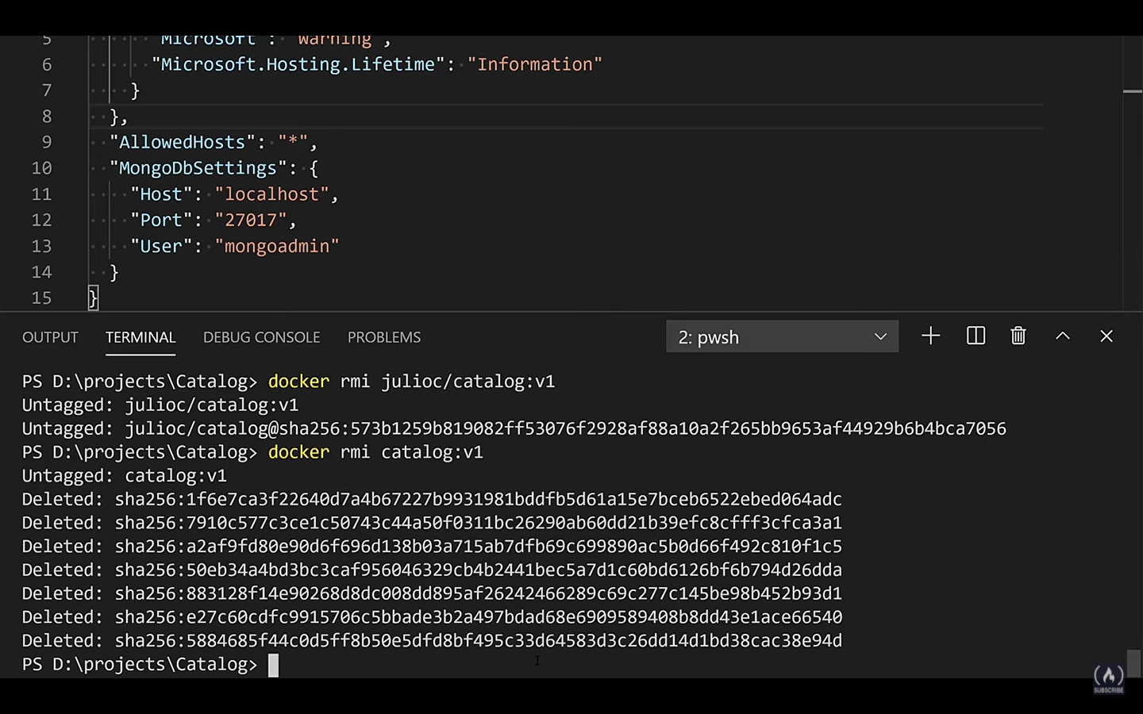

Docker logout is the command to logout from the docker

So to download and run the docker image we can run the same command that we have been running. All this is possible because the image is public only change is the highlighted part

**docker run -it --rm -p 8080:80 -e MongoDbSettings:Host=mongo -e MongoDbSettings:Password=Pass#word1 --network=net5tutorial username/catalog:v1**

Here we are running this command as a user who did not had access to our application ever.

After execution this will download and run that

